# Translated version of Arduino蓝牙多功能车使用手册.htm

**Arduino 蓝牙多功能 车使用手册** **Arduino Bluetooth utility vehicle manual**

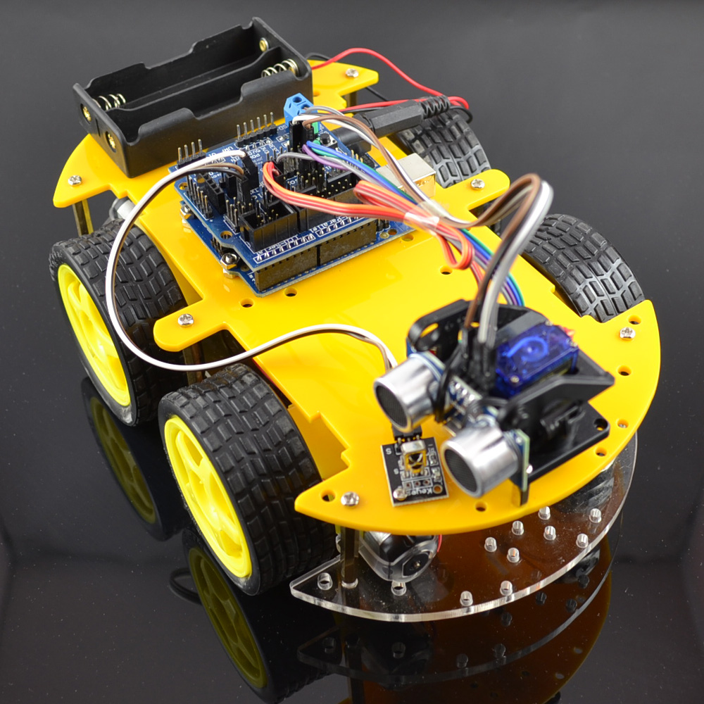<!--[if !vml]--> <!--[endif]-->

**一 ．** **One.** **简介** **Brief introduction**

ARDUINO 蓝牙多功能 车是一款单片机学习应用开发系统 , 以 arduino 单片机系列 atmega-328 为核心 . 完成寻线 , 避障 , 红外遥控和蓝牙遥控的功能 ,. 套件包含了大量的趣味程序，并可扩展外置的电路模块，从而增加小车的使用功能 . 旨在让使用者在学习 ARDUINO 单片机时能脱离枯燥的理论知识，在玩乐中获取单片机系统开发的能力 . ARDUINO Bluetooth utility vehicle is a single-chip learning application development system to arduino microcontroller family atmega-328 core. Complete the hunt, obstacle avoidance, infrared remote control and Bluetooth remote control functions. Package contains a number of interesting programs, and Expansion external circuit module, thereby increasing the car's functionality. designed to allow users in learning ARDUINO microcontroller can from boring theoretical knowledge, the ability to acquire SCM system developed in the play.

**二．** **Two.** **参数** **:** **Parameters:**

1. 电机参数：电压范围： 6-9V, 减速比： 1 比 48 A motor parameters: Voltage Range: 6-9V, reduction ratio: 1 to 48

2. 控制电机选用 L298N 驱动模块，与单片机真正隔离 . 2 control motor selection L298N driver module, microcontroller real isolation.

3. 三组寻线模块 , 检测黑白线，精度更高 , 也可用与防跌落控制 . 3 Three groups hunt module detects black and white lines, higher accuracy, can also be used with anti-drop control.

4. 红外遥控通信模块，组成智能小车遥控系统 . 4 Infrared remote communication module, consisting of the smart car remote control system.

5. 超声波模块 , 小车避障系统 . 5 ultrasonic modules, car obstacle avoidance system.

5. 蓝牙无线 模块 , 可以和手机蓝牙配对遥控机器人 . 5 Bluetooth wireless module can be paired Bluetooth phone remote control robot.

6. 可接入外部 7~12V 的电压。 6 can access the external voltage 7 ~ 12V. 并能搭载多款传感器模块，根据您的想象力实现各种功能 . And can be equipped with a variety of sensor modules to achieve a variety of functions, depending on your imagination.

**三．** **Three.** **实验课程介绍** **Experimental Course Introduction**

1 ． 1. L298N 电机驱动板的应用 L298N motor driver board applications

2 ． 2. 循迹智能车 Smart car tracking

3 ． 3. 超声波避障智能车 Ultrasonic obstacle avoidance Smart Car

4 ． 4. 红外遥控控制智能车 Infrared remote control Smart Car

5 ． 5. Arduino 蓝牙遥控 可编程智能车 Arduino Bluetooth remote control programmable smart car

6 ． 6. 四和一 ( 寻线 避障 红外遥控 蓝牙遥控 ) 多功能程序 Four and one (obstacle avoidance hunt infrared remote Bluetooth remote) multifunction program

**四** **.** **清单** **Four. List**

1. 减速电机 4 个 1 gear motor 4

2. 优质轮胎 4 个 2 high-quality tires 4

3. 电机固定件 4 个 3 motor fixing member 4

4.100*213* 4.100 * 213 * 5MM 5MM 有机玻璃板 1 片 Plexiglass plate 1

5.100*213* 5.100 * 213 * 5MM 5MM 有机玻璃板 1 片 Plexiglass plate 1

6.L298N 电机驱动板 1 个 6.L298N motor driver board 1

7.ARDUINO UNO328 控制板 1 个 7.ARDUINO UNO328 control panel 1

8.ARDUINO 传感器扩展板 V5 1 个 8.ARDUINO sensor expansion board V5 1 个

9. 云台 1 个 9 PTZ 1

10. 舵机 1 个 10. Servo 1

11. 超声波模块 1 个 11 Ultrasonic Module 1

12. 三组寻线模块 12 Three groups hunt module

13. 红外接收传感器 13 IR receiver sensor

14. 单片机遥控器 14 MCU remote control

16.18650 电池盒一个 16.18650 battery box a

17.18650 电池 2 节 Section 17.18650 battery 2

18.18650 充电器 1 个 18.18650 charger 1

19. 蓝牙模块 1 个 19 Bluetooth module 1

20. 杜邦线 30 条 20 DuPont line 30

21.1 米 21.1 m 长 USB 线 1 条 A long USB cable

22. 铜柱 22. Pillars 35MM 35MM 长 6 个 Long 6 20MM 20MM 3 个 3 6MM 6MM 6 个 6

23.3MM 23.3MM 螺丝螺母若干 Several screw nut

**五** **.** **云台舵机安装示意图** **V. head servo installation diagram**

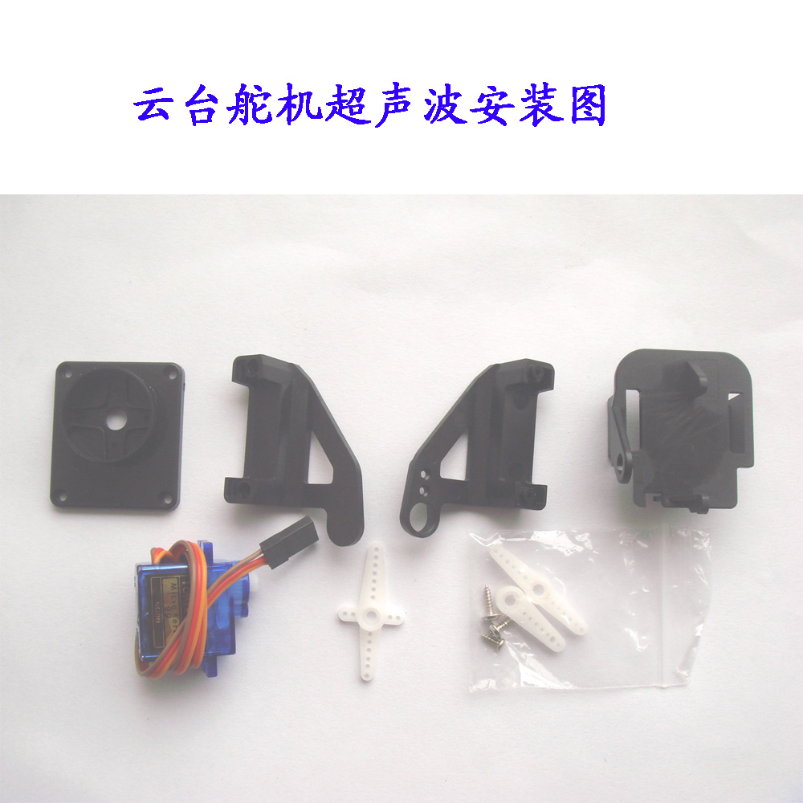<!--[if !vml]--> <!--[endif]-->

Install for ultrasonic, take out the cross, and cut the long legs

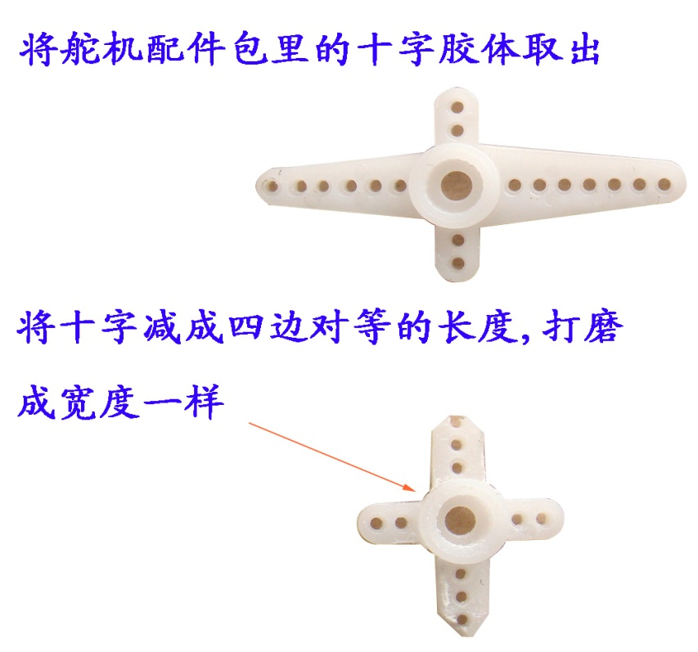<!--[if !vml]--> <!--[endif]-->

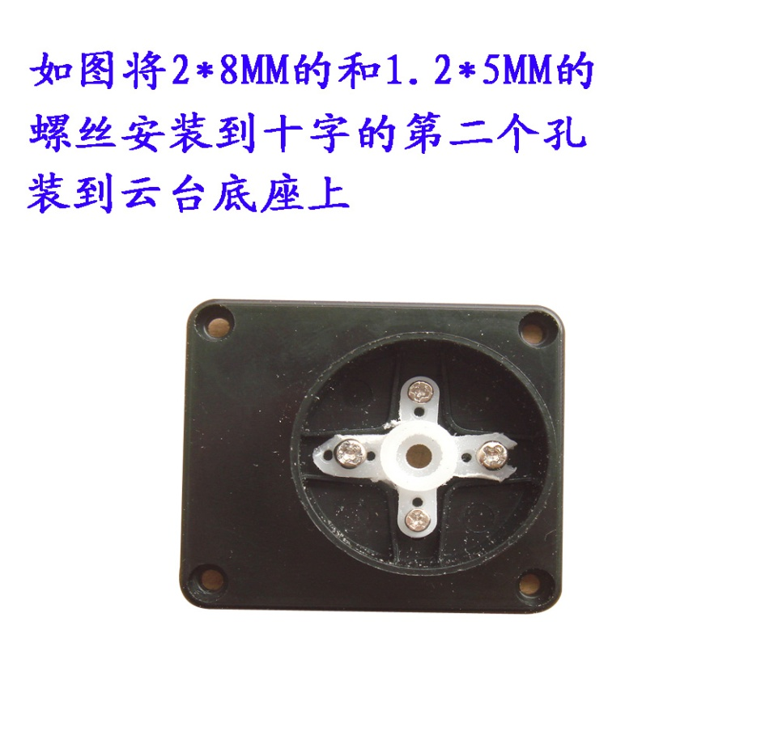<!--[if !vml]--> <!--[endif]--> fix it below the rotation stage

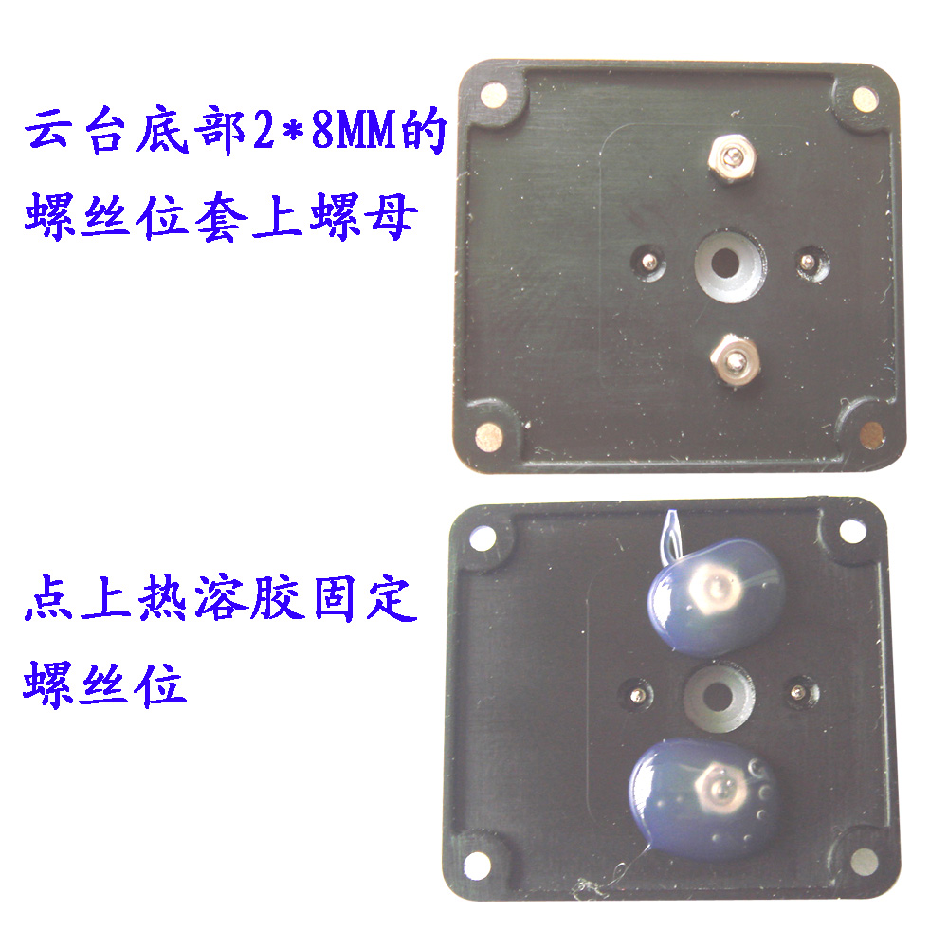<!--[if !vml]--> <!--[endif]-->

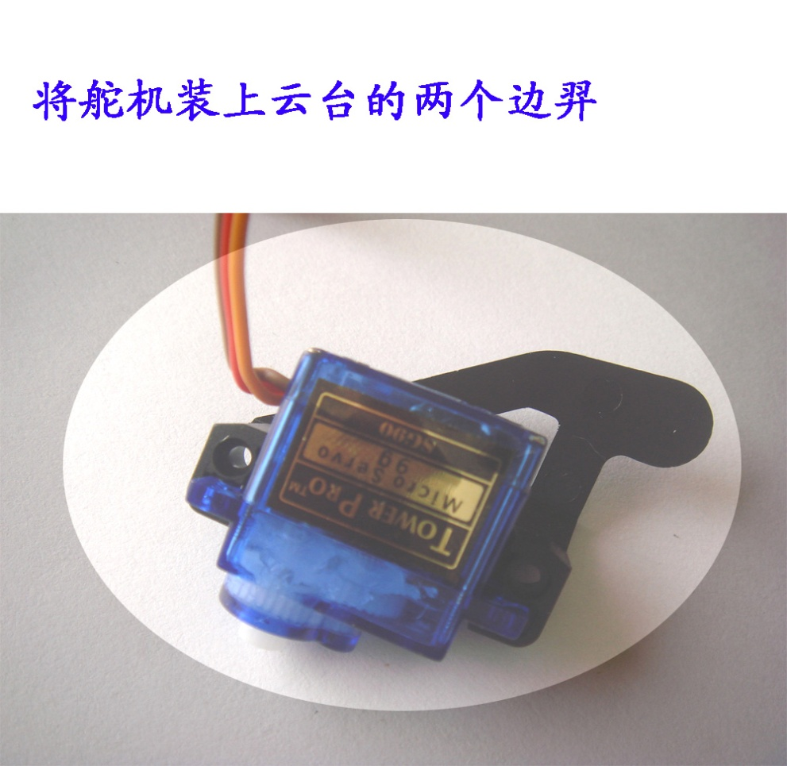<!--[if !vml]--> <!--[endif]--> install the servo motor

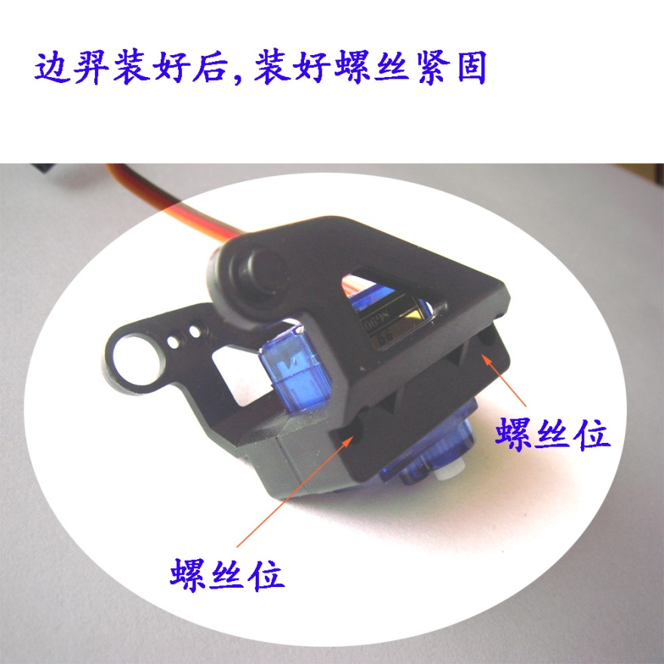<!--[if !vml]--> <!--[endif]-->

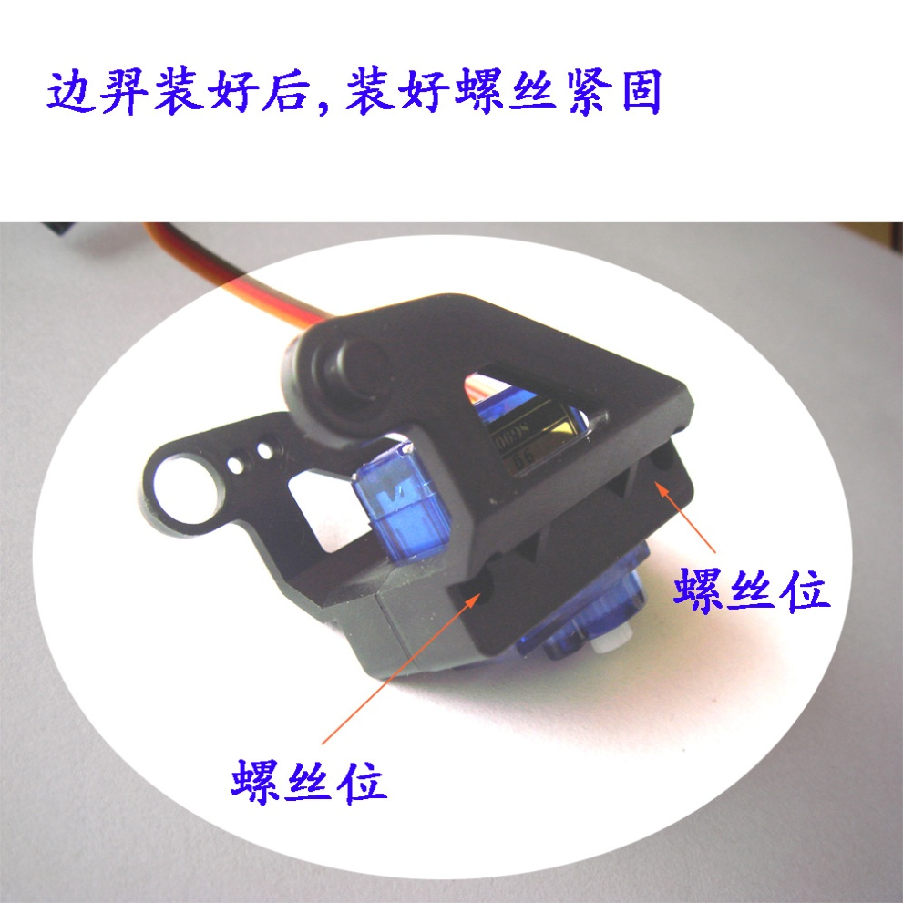<!--[if !vml]--> <!--[endif]-->

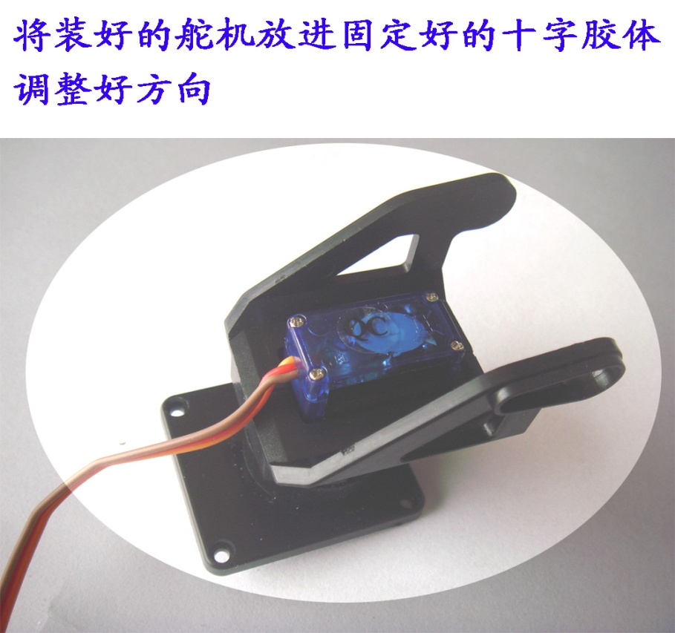<!--[if !vml]--> <!--[endif]-->

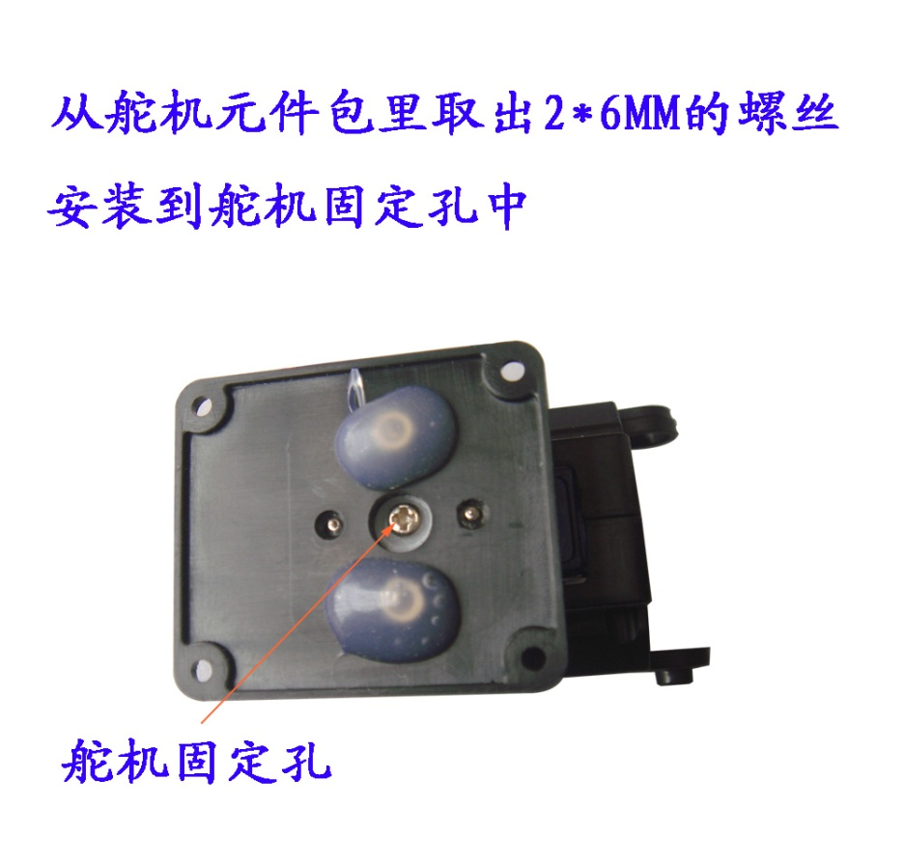<!--[if !vml]--> <!--[endif]-->

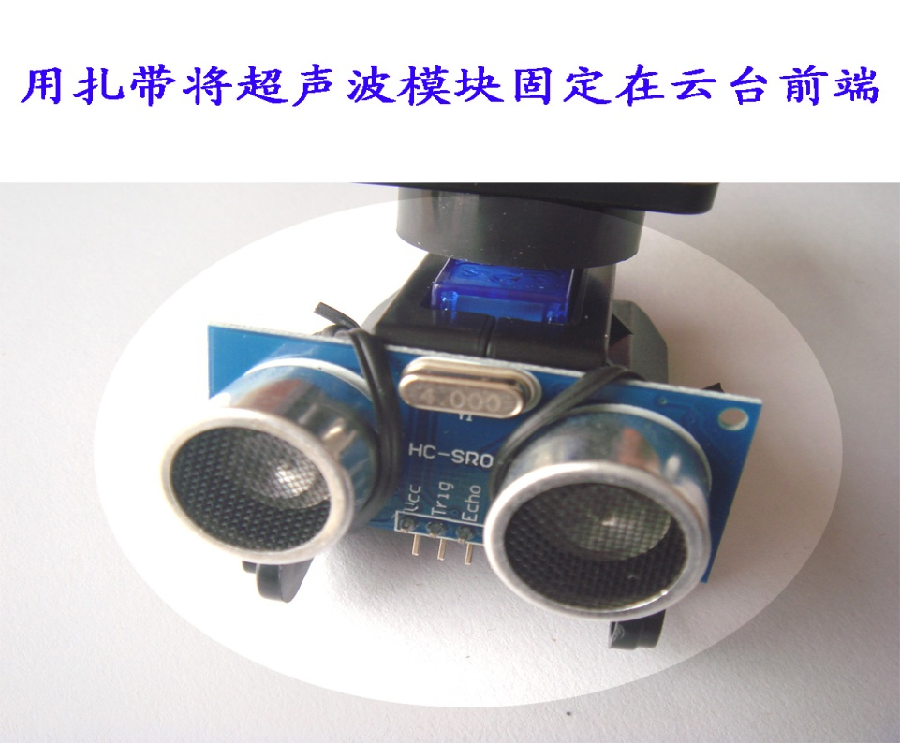<!--[if !vml]--> <!--[endif]--> install the ultrasonic senser

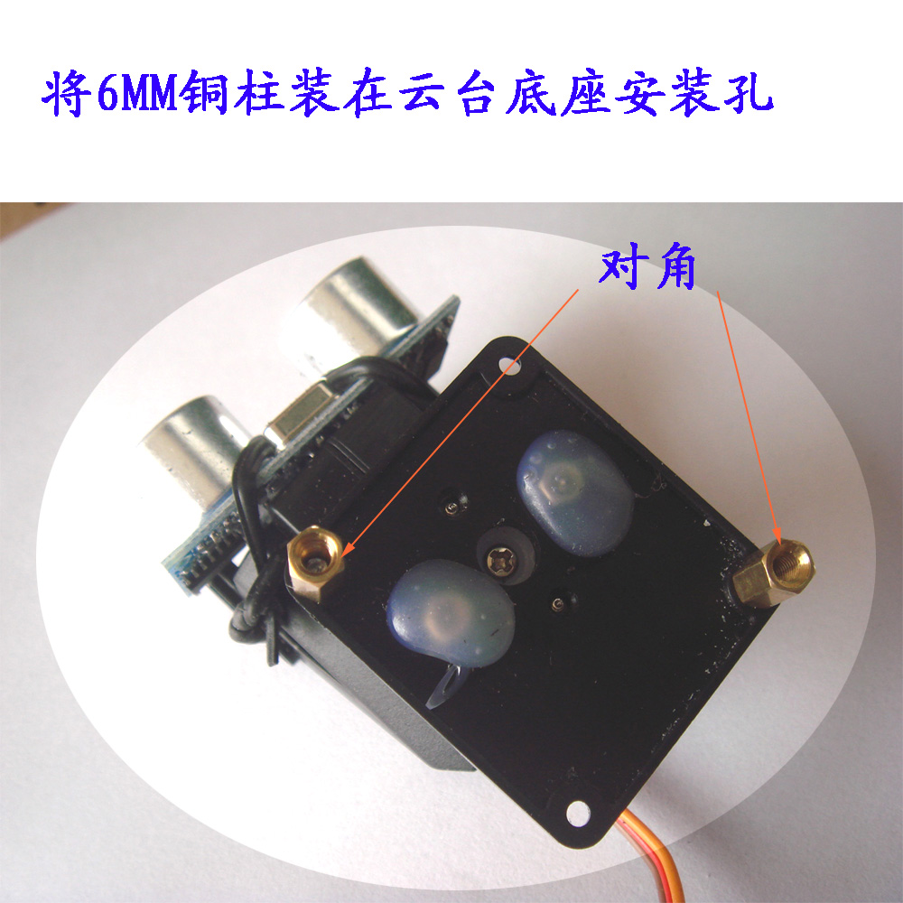<!--[if !vml]--> <!--[endif]-->

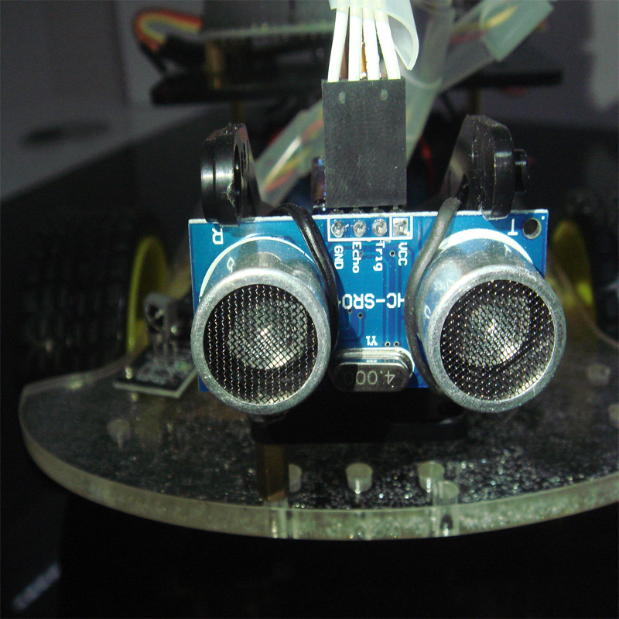<!--[if !vml]--> <!--[endif]-->OK! Enjoy Jim ☺

**六** **.Arduino** **单片机的使用** **Six. Arduino** **microcontroller use**

1. 介绍 1 Introduction

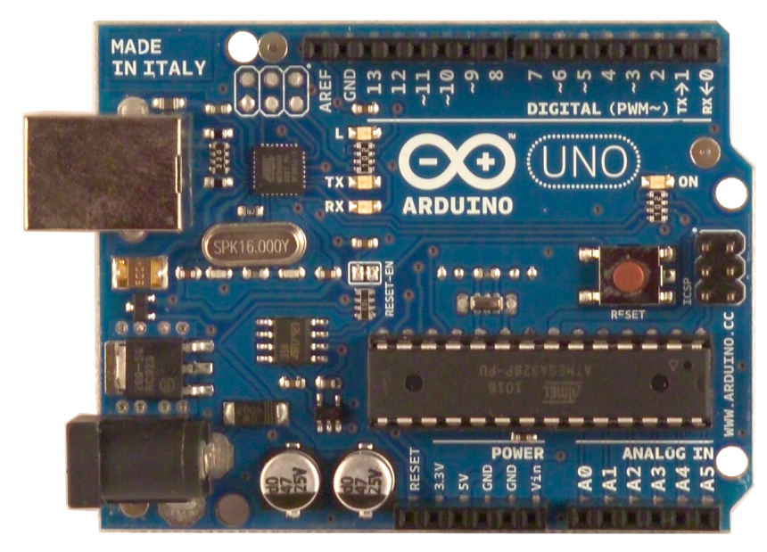<!--[if !vml]--> <!--[endif]-->

Arduino 是源自意大利的一个开放源代码的硬件项目平台，该平台包括一块具备简单 I/O 功能的电路板以及一套程序开发环境软件。 Arduino is an open-source from the Italian project hardware platform that includes a with a simple I / O functions of a circuit board and a set of application development environment software. Arduino 可以用来开发交互产品，比如它可以读取大量的开关和传感器信号，并且可以控制电灯、电机和其他各式各样的物理设备； Arduino 也可以开发出与 PC 相连的周边装置，能在运行时与 PC 上的软件进行通信。 Arduino can be used to develop interactive products, such as it can be read by a large number of switches and sensor signals, and can control lights, motors, and other kinds of physical devices; Arduino can also develop peripheral devices connected to the PC, can and software on the PC to communicate runtime. Arduino 的硬件电路板可以自行焊接组装，也可以购买已经组装好的模块，而程序开发环境的软件则可以从网上免费下载并使用。 Arduino hardware circuit board can be self-welding assembly can also be purchased already assembled modules, and program development environment software you can download and use for free from the Internet.

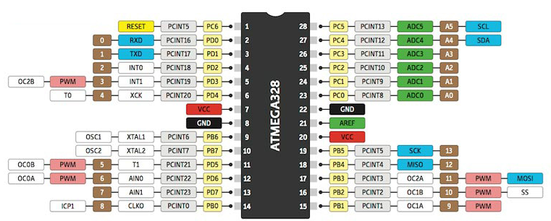<!--[if !vml]--> <!--[endif]-->

我们看看 Arduino 团队如何为其定义的： We look at how to define the Arduino team:

Arduino 是一个开放源码电子原型平台，拥有灵活、易用的硬件和软件。 Arduino is an open-source electronics prototyping platform with a flexible, easy to use hardware and software. Arduino 专为设计师，工艺美术人员，业余爱好者，以及对开发互动装置或互动式开发环境感兴趣的人而设的。 Arduino is designed for designers, arts and crafts workers, hobbyists and people interested in the development of interactive installations or interactive development environment designed for.

Arduino 可以接收来自各种传感器的输入信号从而检测出运行环境，并通过控制光源，电机以及其他驱动器来影响其周围环境。 Arduino can receive input signals from various sensors to detect the operating environment, and by controlling the light source, and the other drive motor to affect their surroundings. 板上的微控制器编程使用 Arduino 编程语言（基于 Wiring ）和 Arduino 开发环境（以 Processing 为基础）。 Microcontroller Arduino board programming using programming language (based on Wiring) and the Arduino development environment (based in Processing). Arduino 可以独立运行，也可以与计算机上运行的软件（例如， Flash ， Processing ， MaxMSP ）进行通信。 Arduino can run independently, can also run on a computer with software (for example, Flash, Processing, MaxMSP) to communicate.

Arduino 硬件电路板可以自行焊接组装，也可以购买已经组装好的，软件则可以从 Arduino 网站免费下载使用。 Arduino hardware board can self-welding assembly can also be purchased already assembled, the software is free to download from the Arduino website. 您可以根据开源许可获得硬件参考设计（ CAD 文件），并自由地修改使其适应您的需求。 You can get an open source license hardware reference design (CAD file), and the freedom to modify it to suit your needs.

Arduino 的定义仍然有点模糊，这也正是 Arduino 的优势所在。 Arduino is still a little fuzzy definitions, which is the Arduino advantage. Arduino 是人们连接各种任务的粘合剂。 Arduino is connected to a variety of tasks that people adhesives. 要给 Arduino 下一个最准确的定义，最好用一些实例来描述。 Arduino give the most precise definition is best described using some examples.

您想当咖啡煮好时，咖啡壶就发出 “ 吱吱 ” 声提醒您吗？ You want coffee brewed, the coffee pot on the issue of "creak" sound to remind you with something?

您想当邮箱有新邮件时，电话会发出警报通知您吗？ If you want to have a new mail message, the phone will alert notifies you do?

想要一件闪闪发光的绒毛玩具吗？ Want a glittering pile toy?

想要一款具备语音和酒水配送功 Want to have a voice and drinks distribution function 能的X Energy X 教授蒸汽朋克风格轮椅吗？ Professor steam punk style wheelchair?

想要一套按下快捷键就可以进行实验测试蜂音器吗？ Want a keyboard shortcut can be carried out experimental tests buzzer it?

想为您的儿子自制一个《银河战士》手臂炮吗？ Want for your son made ​​a "Metroid" arm cannon right?

想自制一个心率监测器，将每次骑脚踏车的记录存进存储卡吗？ Homemade want a heart rate monitor, record each time the cyclists deposited into a memory card?

想过自制一个能在地面上绘图，能在雪中驰骋的机器人吗？ Thought made ​​a drawing can be on the ground, the robot can ride in the snow right?

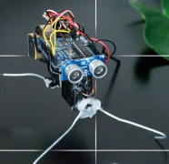<!--[if !vml]--> <!--[endif]--> 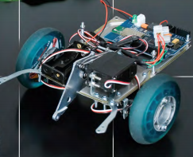<!--[if !vml]--> <!--[endif]-->

Arduino 都可以为您实现。 Arduino think that you can achieve.

对于不了解电子产品或微控制器的人来说，这听上去很酷，很有趣，并且会想加入这个俱乐部。 For understand electronics or microcontrollers people, this sounds very cool, very interesting, and will want to join this club. 这是小孩子想制作的东西，您甚至可以哄他们在此过程中学一些知识。 This is something kids want to make, you can even fool some of their knowledge in this process school. 这些项目产生于科幻小说故事，这些小装置出现在日志里。 These projects generated in the science fiction story, these small devices appear in the log. 其共同之处在于这些是幻想，是一些梦寐以求的东西。 Its common is that these are fantasies, some of the stuff of dreams. 但是现在，这些绝妙的点子真的被实现了，及时您不是工程师，也完全可以自制。 But now, these wonderful ideas really are achieved in a timely manner you are not an engineer, but also completely homemade.

这是个了不起的大事，因为工程师往往为其他工程师设计开发平台，而不是为艺术家，怪咖 ，或者为了分享一个想法而简单地将东西连接起来的小孩子们。 This is a big deal, because engineers are often designed for other engineers to develop a platform, rather than as an artist, freak, or young children in order to share an idea and simply connect things together. Arduino 团队不是由 “ 硬蕊 ” 电子工程师组成，而是由设计师，教师，艺术家，以及我所知道的所有 “ 技术嬉皮士 ” 组成（嬉皮士在这儿是一种称赞，我希望没有冒犯他们）。 Arduino team than by the "hard core" of electronic engineers, but by designers, teachers, artists, and I know all the "technical hippies" component (hippies here is a compliment, I hope I did not offend them). Arduino 的主要基地在意大利，每年我都会看到文章讲述意大利人努力寻找 “ 属于自己的 Google” ，而事实上他们已经有了，那就是 Arduino ，他们尚未意识到这一点。 Arduino's main base in Italy, every year I see people trying to find articles about Italy "own Google", and in fact they already have, and that is Arduino, they have yet to realize it.

看看 Arduino 项目的实例，你将发现制造者们对于这些电子产品 “ 是什么 ” 更加感兴趣，而不是制作方法。 See examples of Arduino projects, you will find these electronics makers are "what is" more interested in, rather than production methods. 这些 Arduino 发烧友常常表示 Arduino 并没有教授基本的电子产品， “ 呸，这哪是真正的电子产品啊， ” 他们说， “ 太容易了！ ” 是的，的确如此。 These enthusiasts often expressed Arduino Arduino does not teach basic electronics, "Bah, could this be true of electronic products ah," they said, "too easy!" Yes, indeed. 如果您是个艺术家或设计人员，在不使用 Arduino 情况下，想让发光二极管闪烁，或者电机转动，那么祝您好运了。 If you are an artist or designer, not using Arduino in case, you want a light emitting diode flashes, or motor rotation, then I wish you good luck. 当然，如果您愿意花钱并且带着您厚重的电子产品技术教材来展示一番，这也未尝不可。 Of course, if you are willing to spend money and take your electronics technology heavy textbooks to show something, which is not a bad idea. 但是对于那儿的其他人而言，他们不过是想用发光二级管来装饰火人节服装而已。 But for there to other people, but they want to use light-emitting diode to decorate Burning Man clothing only.

对于一些传统微控制器社区是如何看待 Arduino 这一问题，我认为最佳的例子就是 AVR Freaks ，该官方网站专注于 AVR 处理器（同样用于 Arduino ）。 For some traditional microcontroller Arduino community is how to treat this issue, I think the best example is the AVR Freaks, the official website focuses on AVR processor (also used Arduino). 您会想 AVR Freaks 社区可能会喜爱 Arduino ，因为 Arduino 能够将 AVR 微控制器带给大众。 You might want to AVR Freaks community favorite Arduino, because Arduino AVR microcontrollers can be brought to the public. 然而，该网站的很多人并不喜欢这些非工程师们制造的所有古怪玩意儿，因为这些会破坏了他们的等级制度。 However, many people do not like all of the site's wacky contraption made ​​of these non-engineers because they will destroy their hierarchy. 我最喜欢引用一句话（我希望把这句话印在Ｔ恤上）。 To quote my favorite (and I hope these words printed on the T-shirt).

“Arduino 编程语言，小孩都能看懂，用一次就上瘾 ”—— ArnoldB ， AVRfreaks 网站 "Arduino programming language that children can understand, once hooked" - ArnoldB, AVRfreaks website

事实上，这种错误的态度却推动 Arduino 粉丝去建立自己的社区，帮助了 Arduino 建立一个兼收并蓄，而非高高在上的社区。 In fact, this was the wrong attitude to promote the Arduino fans to create their own communities, helping to build an eclectic Arduino, rather high above the community.

Arduino 是简单，但不是过于简单。 Arduino is simple, but not too simple. 它围绕这些观点来建立，即学生使用 Arduino 去实现目的：接收传感器信号，获得一些代码，再利用这些信号和代码。 It revolves around these ideas to create that students use Arduino to achieve the purpose of: receiving sensor signals, to get some code, and then use these signals and codes. 或许甚至不会写代码，那他们剪切粘贴代码后就可以开始。 Perhaps not even write code, you can begin after that they cut and paste code. Arduino 是热粘结剂，而非精确的焊接。 Arduino is a thermal adhesive, rather than precise welding. 因此没有人会被切掉一只手，也不会有实验室被烧毁。 So no one will be cut off one hand, there will not be labs were destroyed. Arduino 团队成员之一会教授工艺美术人员和设计者如何使用。 One Arduino team members will teach arts and crafts people and designers how to use. 每天， Arduino 在学习，教授，和共享代码的工程中不断建立和完善。 Every day, Arduino constantly establish and improve learning, professors, and shared code project. 这些工艺美术人员和设计者正在 Macs 系统上使用 Processing 语言并修改。 The arts and crafts people and designers to use and modify the Processing language systems are Macs. （ Processing 是 Arduino 的老大哥） (Processing is Arduino's Big Brother)

说到此处， Arduino 就像是一个热情，没有界限，艺术氛围浓厚的集会。 Speaking here, Arduino is like a passion, no boundaries, artistic atmosphere of the rally. 这就是 Arduino 成为 “ 自己动手做 ” 成功典范的原因吗？ This is the Arduino become a "do it yourself" successful model of reason? 不仅仅如此，我们来了解更多具体信息。 Not only that, we come to understand more specific information.

程序库 —— 简单任务，复杂任务轻松搞定 Library - simple tasks, complex tasks easy to get

大量的封装库被用来完成复杂的任务，例如写入 SD 记忆卡，写入液晶显示屏驱动程序，解析 GPS 。 A large package library is used to perform complex tasks, such as writing to the SD memory card, write LCD driver, parsing GPS. 也有一些程序库用来做简单的事情，比如转动插脚或按键消抖。 There are also some libraries used to do simple things, such as turning the pin or key debounce. 如果有 10 个芯片，我们就得将 UART 安装代码写 10 次，坦白说，这让人厌烦。 If there are 10 chips, we have to install the UART code written 10 times, and frankly, it annoying. 如果调用 Serial.begin(9600) 函数来处理寄存器数据的话，那就容易多了。 If you call Serial.begin (9600) function to handle the register data, then it is much easier.

轻量型，直接运行在硬件底层 Lightweight, run directly on the underlying hardware   上 On

使用一款经认证的，易于理解的编译器（我们甚至可以说 avr-gcc 是 AVR 默认或标准的编译器），代码能直接运行在硬件底层 Use a certified, easy to understand compilers (We can even say that is the AVR avr-gcc compiler default or standard), the code can be run directly on the underlying hardware   上。 On. 其编译方式与 NET 语言及 BASIC 语言不同。 NET languages ​​compile manner and BASIC language is different. 该编译器运行快，体积小，重量轻， 并且您能使用 HEX （十六进制）文件为成批的新芯片进行编程。 The compiler runs fast, small size, light weight, and you can use HEX (hexadecimal) file for the bulk of the new chip to be programmed.

传感器 Sensor

Arduino 真正腾飞的原因是其能够实现将模拟输入转换为数字输入，换言之，您可以将光线，温度，声音，或者市场上已有的任何低成本的传感器信号输入， Arduino 都能识别。 Arduino really take off because it enables analog input into digital input, in other words, you can light, temperature, sound, or any already on the market of low-cost sensor signal input, Arduino can be identified. 对于数字传感器， Arduino 支持 SPI （ 高速同步串行口）和 I For digital sensors, Arduino supports SPI (high-speed synchronous serial port) and I 2C 2C 总线。 The bus. 这一功能覆盖市场上 99% 的传感器。 This feature covers 99% of the sensors on the market. 使用其他开发平台是不易实现的 —— 想想如果把一块 Beagleboard （伟大的产品）和 Arduino 绑在一起，仅仅是为了获得传感器的数据，那真是太奇怪了！ Other development platform is not easy to achieve - think if a Beagleboard (great product) and Arduino tied together, just to get the data of the sensor, it is really strange!

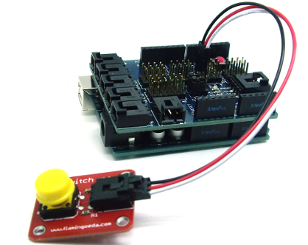<!--[if !vml]--> <!--[endif]-->

简单，但不至于太简单 Simple, but not too simple

传统开发板往往过于复杂，有很多附件，例如液晶显示屏，按钮，发光二级管，７段数码管等等。 Traditional development boards are often too complex, there are many accessories, such as LCD screen, buttons, LEDs, 7-segment digital tube and so on. 开发板展示了其一切功能。 Development board shows all its functions. Arduino 板上显示的功能数量是绝对最小值，如果要实现功能扩展，只需增加 Shield （盾）。 The number of functional Arduino board shows the absolute minimum, if you want to expand the functions, simply increase the Shield (shield). Arduino Shield 有成百上千，从液晶显示屏到无线上网技术，但要增加多少 Shield 由用户自己定。 Arduino Shield There are hundreds, from LCD to wireless Internet technology, but to increase the number of Shield set by the user. 扩展 Shield 的功能也容易，对于制作扩展 Shield 功能的人还会有商业上的刺激。 Expansion Shield features are also easy to make extensions Shield features people will stimulate commerce.

非芯片制造商制造 Non-chip maker manufacture

Arduino 开发板不是由芯片制造商设计的。 Arduino development board is not designed by the chip manufacturer. 为什么强调这点呢？ Why emphasize this point? 因为芯片制造商为了突出自己的产品与众不同，他们常常会添加一些奇怪的东西。 Because the chip maker in order to highlight their products unique, they often add some strange things. 而 Arduino 强调微控器间的共同性而不是差异性。 The Arduino emphasize commonalities rather than differences between the microcontroller. 这就意味着 Arduino 是一个绝佳的初学者平台，只要在 Arduino 板上可以做的事情，您在其他任何的微控制器上都可以做。 This means that the Arduino is a great platform for beginners, as long as the Arduino board can do things that you can do on any other microcontroller. 这一基本特征将伴随您很长时间。 The basic features will accompany you for a long time.

2. Arduino 驱动的安装及程序的烧写 2 Arduino-driven installation and programming procedures

首先下载 Arduino 的开发软件， web 地址： [http://arduino.cc/en/Main/Software](http://translate.google.com/translate?hl=en&prev=_t&sl=zh-CN&tl=en&u=http://arduino.cc/en/Main/Software) First, download the Arduino development software, web address: [http://arduino.cc/en/Main/Software](http://translate.google.com/translate?hl=en&prev=_t&sl=zh-CN&tl=en&u=http://arduino.cc/en/Main/Software)

下载下来的文件是一个 arduino-0023.zip 的压缩文件夹，解压出来到硬盘。 Downloaded file is a arduino-0023.zip compressed folder, extract it to your hard drive.

将 Arduino UNO 通过 USB 线连接到 Windows 时，就会提示有名为 “ Arduino UNO“ 的新 USB 设备找到， When the Arduino UNO connected to Windows via USB cable, you will be prompted new USB device named "Arduino UNO" is found,

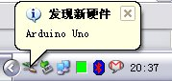<!--[if !vml]--> <!--[endif]-->

接着 Windows 会引导我们进入 “ 找到新的硬件向导 ” 窗口，选取其中的 “ 否，暂时不 ” 选项后单击 “ 下一步 ” 按钮： Then Windows will guide us into the "Found New Hardware Wizard" window, select one of the "No, not" option, click "Next" button:

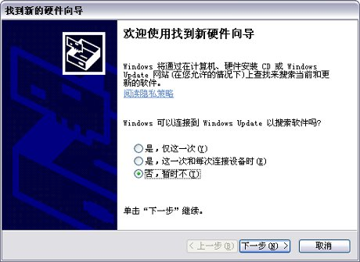<!--[if !vml]--> <!--[endif]-->

接下来的步骤需要安装 Arduino UNO 所需的驱动，选取其中的 “ 从列表或指定位置安装（高级） ” 选项后单击 “ 下一步 ” 按钮： The next step you need to install the necessary drivers Arduino UNO, select one of the "Install from a list of specific location (Advanced)" option, click "Next" button:

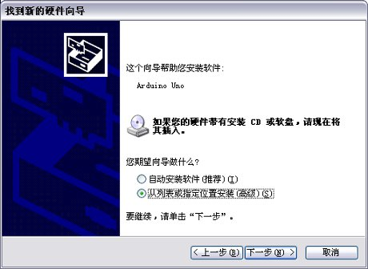<!--[if !vml]--> <!--[endif]-->

Arduino UNO 的 USB 驱动放在 Arduino 0021 安装目录下的 drivers 目录中，我们需要为 Windows 指明该目录为安装驱动时搜索的目录： Arduino UNO USB drive on drivers directory Arduino 0021 installation directory, we need to specify the directory for Windows installation directory-driven search:

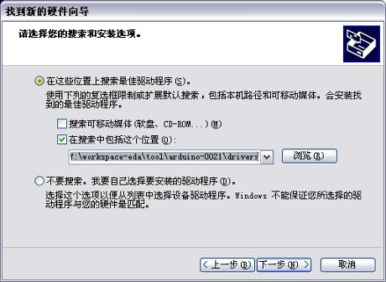<!--[if !vml]--> <!--[endif]-->

单击 “ 下一步 ” 按钮后， Windows 就开始查找并安装 Arduino UNO 的 USB 驱动程序： Click the "Next" button, Windows will begin to find and install Arduino UNO USB drivers:

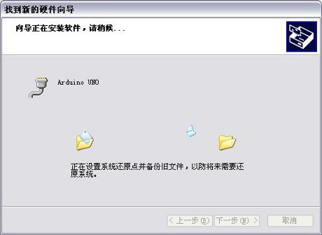<!--[if !vml]--> <!--[endif]-->

如果一切正常的话，我们将看到如下的成功界面： If everything goes well, we will see the following screen success:

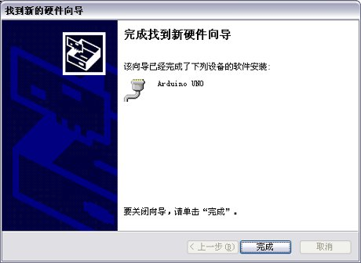<!--[if !vml]--> <!--[endif]-->

Arduino UNO 的 USB 驱动安装成功之后，我们可以在 Windows 设备管理器中找到相应的 Arduino UNO 串口： Arduino UNO after the USB driver installation is successful, we can find the appropriate Arduino UNO serial ports in Windows Device Manager:

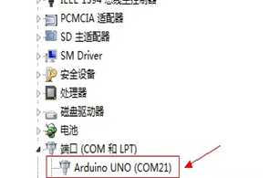<!--[if !vml]--> <!--[endif]-->

下面示范第一个程序的烧写，点亮“ L ”灯 The following program demonstrates the first programmer, light "L" lights

在 Arduino-0023 的编程界面，点击【 Tools 】，将鼠标移动到下拉菜单 的【 Board 】选项，在继续弹出的子菜单中看，【 Arduino UNO 】前面是否有一个黑点，如果不是，则点一下【 Arduino UNO 】这个选项。 In Arduino-0023 programming interface, click [Tools], move the mouse to the drop-down menu [Board] option in the pop-up submenus seen continuing, [Arduino UNO] if there is a black spot in front of, if not, then the point Click [Arduino UNO] this option.

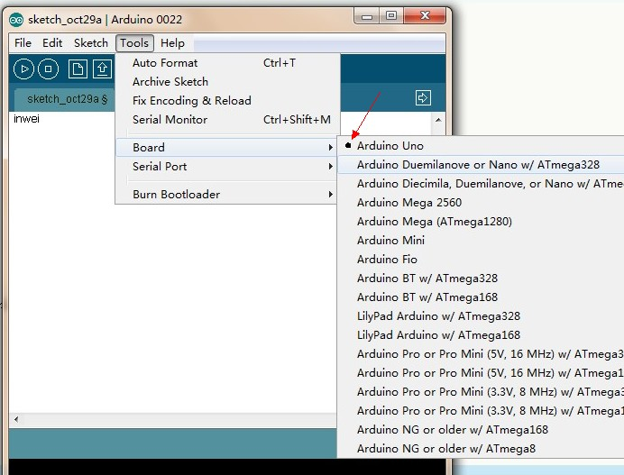<!--[if !vml]--><!--[endif]-->

下来要选择正确的 COM 连接。 Down to select the correct COM connection. 还记得刚才安装硬件的时候的要求你记录下来的那个（ COMX ）的 X 的值么？ Just remember when installing the hardware requirements of your record that (COMX) What's the value of X? 这里就要用到。 Necessary to use here. 如刚才安装的 Arduino UNO 的端口就是 21 ，所以鼠标就点选 21. If Arduino UNO port just installed is 21, so the mouse click 21.

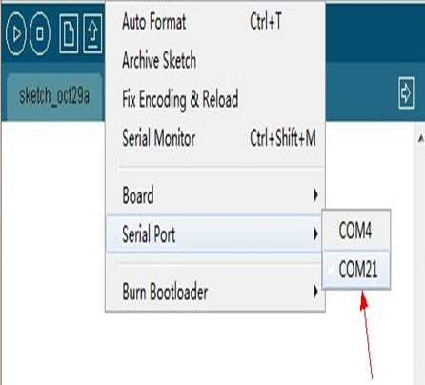<!--[if !vml]--> <!--[endif]-->

再来导入一个让“ L ”灯闪烁的示例程序，鼠标左键点【 File 】 Let come to import a "L" flashing lights sample program, the left mouse button [File]

在弹出的下拉菜单里面移动鼠标到【 Examples 】，菜单向右边扩展到【 1.Basics 】 Inside the pop-up menu, move the mouse to pull down [Examples], the menu extend to the right to [1.Basics]

鼠标移动到【 1.Basics 】之后，菜单继续展开，找到【 Blink 】，鼠标左键单击【 Blink 】 Move the mouse to [1.Basics] After the menu continues to expand, find the [Blink], left-click [Blink]

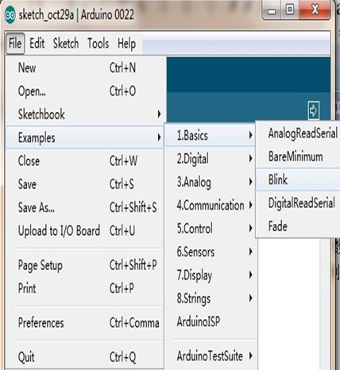<!--[if !vml]--> <!--[endif]-->

单击完【 Blink 】，会弹出一个 Arduino 编程界面 Click End [Blink] will pop up a Arduino programming interface

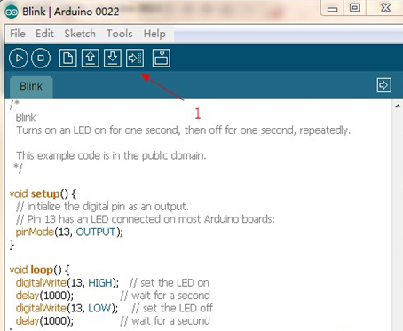<!--[if !vml]--> <!--[endif]-->

<!--[if !vml]--><!--[endif]--> 直接点左图红色箭头 1 所指的的图标，会发现， Arduino UNO 主板上会有两个黄色的灯会闪一阵，随着两个狂闪的黄色灯熄灭。 Direct point left a red arrow icon within the meaning of, you will find the Arduino UNO motherboards have two yellow light will flash for a while, along with two wild yellow flashing lights off. 编程框下方出现文字提示 ， Text prompt box appears below the program,

主板上的 L 灯以 1 秒一次亮灭 。 L lights on the motherboard with 1 second blinking.

那么恭喜你，你的第一个程序已经成功了！ So congratulations, you first program has been a success! ！ ! ！ !

**七．** **VII.** **实验详细介绍** **Experimental Details**

**1.L298N 电机驱动板的应用** **1.L298N motor driver board applications**

L298N 桥驱动板说明请参考（ L298N 双 H 桥直流电机驱动板手册），这里就不再说了，不过还有一些网友不清楚怎么控制两路直流电机，这里做一下详细说明。 L298N bridge driver board Please refer to (L298N dual H-bridge DC motor driver board manual), here is not to say, but there are some users do not know how to control two DC motors, here to do some detail.

<!--[if !vml]--> <!--[endif]-->

首先 VMS 驱动部分取电可接外接电源 , 一般是 9V 左右比较合适，逻辑部分可板内取电，即端子可悬空，也可接入 +5V-+7V 。 First VMS driver to take power section can be accessed by an external power supply, usually around 9V more appropriate, logical part of the board can take power, that the terminal may be left unconnected, but also access to +5 V-+7 V. 端子左右两排三个插针分别用来控制两路直流电机。 About two rows of three terminal pins are used to control two DC motors. EA 、 EB 接入 ArduinoPWM 接口用于电机调速， I1 、 I2 、 I3 、 I4 接口，分别用来控制两路直流电机前进、后退、转向以及刹车，只需接入 Arduino 的数字接口即可。 EA, EB access ArduinoPWM interfaces for motor control, I1, I2, I3, I4 interfaces are used to control two DC motors forward, backward, steering and brakes, only digital interface to access Arduino.

到此准备工作基本完成，可以编写程序了，这里我把小车直走、后退、左转、右转、刹车的功能都编写进程序供大家参考。 This preparatory work completed, you can write a program, and here I put the car straight, backward, turn left, turn right, brake functions are written into the program for your reference.

程序如下： Procedures are as follows:

int pinI1=8;// 定义 I1 接口 int pinI1 = 8 ;/ / define interfaces I1   
int pinI2=9;// 定义 I2 接口 int pinI2 = 9 ;/ / define I2 interfaces   
int speedpin=11;// 定义 EA(PWM 调速 ) 接口 int speedpin = 11 ;/ / define EA (PWM control) Interface   
int pinI3=6;// 定义 I3 接口 int pinI3 = 6 ;/ / define I3 Interface   
int pinI4=7;// 定义 I4 接口 int pinI4 = 7 ;/ / define I4 Interface   
int speedpin1=10;// 定义 EB(PWM 调速 ) 接口 int speedpin1 = 10 ;/ / define EB (PWM control) Interface

void setup() void setup ()   
{ {   
pinMode(pinI1,OUTPUT); pinMode (pinI1, OUTPUT);   
pinMode(pinI2,OUTPUT); pinMode (pinI2, OUTPUT);   
pinMode(speedpin,OUTPUT); pinMode (speedpin, OUTPUT);   
pinMode(pinI3,OUTPUT); pinMode (pinI3, OUTPUT);   
pinMode(pinI4,OUTPUT); pinMode (pinI4, OUTPUT);   
pinMode(speedpin1,OUTPUT); pinMode (speedpin1, OUTPUT);

} }   
void loop() void loop ()

{ {

// 直走 / / Straight

analogWrite(speedpin,100);// 输入模拟值进行设定速度 analogWrite (speedpin, 100) ;/ / set the speed of the input analog value   
analogWrite(speedpin1,100); analogWrite (speedpin1, 100);   
digitalWrite(pinI4,LOW);// 使直流电机（右）逆时针转 digitalWrite (pinI4, LOW) ;/ / make DC motor (right) turn counterclockwise   
digitalWrite(pinI3,HIGH); digitalWrite (pinI3, HIGH);   
digitalWrite(pinI1,LOW);// 使直流电机（左）顺时针转 digitalWrite (pinI1, LOW) ;/ / make DC motor (left) clockwise   
digitalWrite(pinI2,HIGH); digitalWrite (pinI2, HIGH);

delay( 2000); delay (2000);

// 后退 / / Back

analogWrite(speedpin,100);// 输入模拟值进行设定速度 analogWrite (speedpin, 100) ;/ / set the speed of the input analog value   
analogWrite(speedpin1,100); analogWrite (speedpin1, 100);   
digitalWrite(pinI4,HIGH);// 使直流电机（右）顺时针转 digitalWrite (pinI4, HIGH) ;/ / make DC motor (right) clockwise   
digitalWrite(pinI3,LOW); digitalWrite (pinI3, LOW);   
digitalWrite(pinI1,HIGH);// 使直流电机（左）逆时针转 digitalWrite (pinI1, HIGH) ;/ / make DC motor (left) turn counterclockwise   
digitalWrite(pinI2,LOW); digitalWrite (pinI2, LOW);

delay( 2000); delay (2000);

// 左转 / / Left

analogWrite(speedpin,60);// 输入模拟值进行设定速度 analogWrite (speedpin, 60) ;/ / set the speed of the input analog value   
analogWrite(speedpin1,60); analogWrite (speedpin1, 60);   
digitalWrite(pinI4,LOW);// 使直流电机（右）逆时针转 digitalWrite (pinI4, LOW) ;/ / make DC motor (right) turn counterclockwise   
digitalWrite(pinI3,HIGH); digitalWrite (pinI3, HIGH);   
digitalWrite(pinI1,HIGH);// 使直流电机（左）逆时针转 digitalWrite (pinI1, HIGH) ;/ / make DC motor (left) turn counterclockwise   
digitalWrite(pinI2,LOW); digitalWrite (pinI2, LOW);

delay( 2000); delay (2000);

// 右转 / / Right

analogWrite(speedpin,60);// 输入模拟值进行设定速度 analogWrite (speedpin, 60) ;/ / set the speed of the input analog value   
analogWrite(speedpin1,60); analogWrite (speedpin1, 60);   
digitalWrite(pinI4,HIGH);// 使直流电机（右）顺时针转 digitalWrite (pinI4, HIGH) ;/ / make DC motor (right) clockwise   
digitalWrite(pinI3,LOW); digitalWrite (pinI3, LOW);   
digitalWrite(pinI1,LOW);// 使直流电机（左）顺时针转 digitalWrite (pinI1, LOW) ;/ / make DC motor (left) clockwise   
digitalWrite(pinI2,HIGH); digitalWrite (pinI2, HIGH);

delay( 2000); delay (2000);

// 刹车 / / Brake   
digitalWrite(pinI4,HIGH);// 使直流电机（右）刹车 digitalWrite (pinI4, HIGH) ;/ / make DC motor (right) brake

digitalWrite(pinI3,HIGH); digitalWrite (pinI3, HIGH);   
digitalWrite(pinI1,HIGH);// 使直流电机（左）刹车 digitalWrite (pinI1, HIGH) ;/ / make DC motor (left) brake

digitalWrite( pinI2,HIGH); digitalWrite (pinI2, HIGH);

delay( 2000); delay (2000);   
} }

注：程序里我所用的左转和右转只是转弯的一种控制方式，其他方式就不一一列举了，大家可以自己尝试。 Note: The program I used to turn left and turn right just turn in a controlled manner, otherwise not list them, you can try it yourself.

**2. 循迹智能车** **2 Smart car tracking**

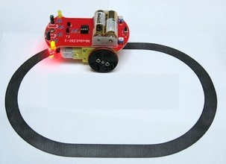<!--[if !vml]--> <!--[endif]-->

循迹模块原理： TCRT5000 红外对管的工作原理是利用红外线对颜色的反射率不一样，将反射信号的强弱转化成电流信号。 Tracking module principle: TCRT5000 infrared tube works is the use of infrared reflectivity of color is not the same, the intensity of the reflected signal is converted into a current signal. 黑白寻迹模块在检测到黑色高电平有效，检测到白色是为低电平有效，检测高度为 0— Black and white tracing module detects a black high efficient white is detected active low, detection height of 0 - 3cm 3cm 。 .

注：在电路中你可以使用旋钮电位器来调黑白寻迹的灵敏度。 Note: You can use the circuit potentiometer knob to adjust the sensitivity of the black and white tracing.

TCRT5000 红外对管在机器人设计，工业制造中应用十分广泛。 TCRT5000 infrared tube in robot design, is widely used in industrial manufacturing. 可利用 TCRT5000 制作黑白寻迹机器人、工业计数传感器等等。 Available in black and white tracing TCRT5000 making robots, industrial counting sensors.

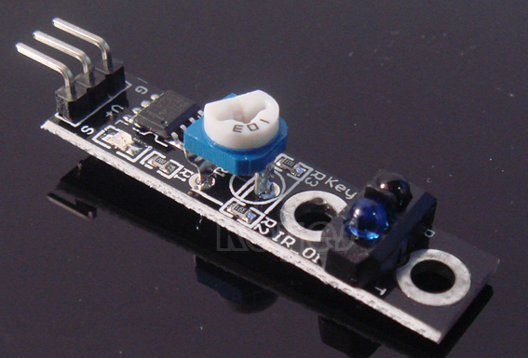<!--[if !vml]--> <!--[endif]-->

使用方法： Usage:   
1. 传感器接口有 3 根排针，分别是 GND ， VCC ， OUT 。 1 sensor interface has three rows of pins, respectively, GND, VCC, OUT. VCC 和 GND 为供电端， OUT 是信号输出端。 VCC and GND for the supply side, OUT is the signal output.   
2. 检测到物体，信号端输出低电平；未检测到物体，信号端输出高电平。 (2) an object is detected, the low level output signal terminal; no object is detected, the signal-side output high.   
3. 主要判断信号输出端是 0 或者 1 ，就能判断物体是否存在。 3 main judgment signal output is 0 or 1, you can determine whether the object exists.

性能参数： Performance parameters:   
1 ：检测距离，检测白纸时约为 1: detection distance, testing about White 2 厘米 2 cm 。 . 视颜色的不同距离有所不同，白色最远。 Depending on the type of color different from white farthest.   
2. 供电电压： 2.5V~12V, 不要超过 12V 。 2 Supply voltage:. 2.5V ~ 12V, do not exceed 12V. ( 注意：最好用低电压供电，供电电压太高传感器的寿命会变短。 5V 供电为佳。 ) (Note: It is best to use a low voltage power supply, the power supply voltage is too high sensor life becomes shorter 5V power supply is better.)   
3. 工作电流， 5V 时 18~20ma 。 3. Operating current, 5V when 18 ~ 20ma. 经大量测试，传感器硬件设置为 18~20ma 工作电流时性能最佳，主要表现在抗干扰能力上。 After extensive testing when the sensor hardware is set to 18 ~ 20ma Current best performance, mainly in the anti-jamming capability.

4. 检测到物体，信号端输出低电平；未检测到物体，信号端输出高电平。 4 object is detected, the low level output signal terminal; no object is detected, the signal-side output high.   
5. 传感器输出 TTL 电平，能直接与 3.3V 或者 5V 单片机 IO 口相连。 5 TTL level sensor output can be connected directly to the 3.3V or 5V microcontroller IO port.

黑线或者白线检测原理 Black or white line detection principle   
1. 利用黑色对光线的反射率小这个特点，当平面的颜色不是黑色时，传感器发射出去的红外光被大部分反射回来。 1 Use small black light reflectance of this feature, when the plane's color is not black, the sensor emitted infrared light reflected back by the majority. 于是传感器输出低电平 0 。 So low sensor output level 0.   
2. 当平面有一黑线，传感器在黑线上方时，因黑色的反射能力很弱，反射回来的红外光很少，达不到传感器动作的水平，所以传感器还输出 1 。 (2) When there is a flat black line, black line sensor in the party, because black reflective capacity is weak, reflected infrared light rarely reach the action level sensor, the sensor also outputs 1.   
3. 我们只要用单片机判断传感器的输出端是 0 或者是 1 ，就能检测黑线。 (3) We just use the microcontroller to determine the output of the sensor is 0 or 1, will be able to detect the black line.   
4. 检测白线的原理和检测黑线的原理一样，检测白线时，白线周边的颜色也要比较接近黑色，然后调节红外传感器上面的可调电阻，将灵敏度调低，一直调到刚好周边的颜色检测不到为止，那样就能检测白线了。 4 white line detection principle and the principle of detecting the black line, like the detection of the white line, white line around the black color also relatively close, and then adjust the infrared sensor above the adjustable resistance, reduced sensitivity has been adjusted to just The color is not detected until the periphery, so you can detect the white line.

实验程序： Experimental procedure:   
  
int pin=7;// 定义检测接口为 Arduino 数字 pin7 int pin = 7 ;/ / Defines interface Arduino digital pin7   
int val;// 定义变量 int val ;/ / define variables   
void setup() void setup ()   
{ {   
pinMode(ledPin,OUTPUT);// 设定数字接口 7 为输出接口 pinMode (ledPin, OUTPUT) ;/ / set the digital interface output interface 7   
Serial.begin(9600);// 设置串口波特率为 9600kbps Serial.begin (9600) ;/ / set the serial port baud rate to 9600kbps   
} }   
void loop() void loop ()   
{ {   
val=digitalRead(pin);// 读取数字接口的值 value val = digitalRead (pin) ;/ / read digital interface   
Serial.println(val);// 输出数字接口的值 Serial.println (val) ;/ value / output digital interface   
} }

**循迹小车** **Tracking car**

了解寻线模块后我们开始做一款属于自己的寻线小车 Learn hunt module after we started doing a hunt of their own car

本设计是一种基于 Arduino 控制的简易自动寻迹小车系统，包括小车系统构成软硬件设计方法。 The design is based on a simple Arduino control system automatically tracing the car, including the trolley system configuration of hardware and software design methods. 小车以 Arduino UNO 为控制核心 , 利用红外光电传感器对路面黑色轨迹进行检测 , 并将路面检测信号反馈给 Arduino 单片机。 Car with Arduino UNO as the control center, using infrared photoelectric sensors to detect trace black pavement and road surface detection signal back to the Arduino microcontroller. Arduino 单片机对采集到的信号予以分析判断 , 及时控制驱动电机以调整小车转向 , 从而使小车能够沿着黑色轨迹自动行驶 , 实现小车自动寻迹的目的。 Arduino microcontroller signal collected are analyzed to determine, in a timely manner to control the drive motor to adjust the car turned, allowing the car to automatically drive along the black track to achieve car automatically tracing purposes.

设计一个基于直流电机的自动寻迹小车，使小车能够自动检测地面黑色轨迹，并沿着黑色车轨迹行驶。 Based on the design of a DC motor automatically tracing the car, so the car can automatically detect ground black track, and a black car traveling along the track. 系统方案方框图如图 1-1 所示。 System solutions block diagram shown in Figure 1-1.

<!--[if !vml]--> <!--[endif]-->

|  |
| --- |
| 检测（黑线） |

|  |
| --- |
| 驱动电机 |

|  |
| --- |
| 软件控制 |

|  |
| --- |
| 控制小车 |

图 1-1 系统方案方框图 Block diagram of Figure 1-1 System program

小车循迹原理 Car tracking principle

这里的循迹是指小车在白色地板上循黑线行走，由于黑线和白色地板对光线的反射系数不同，可以根据接收到的反射光的强弱来判断“道路”。 Here is the tracking on the trolley through the black line white floor, the floor of the black and white lines of the different light reflection coefficients, according to the strength of the received reflected light to determine the "road." 通常采取的方法是红外探测法。 The method is usually taken infrared detection method.

  红外探测法，即利用红外线在不同颜色的物体表面具有不同的反射性质的特点，在小车行驶过程中不断地向地面发射红外光，当红外光遇到白色纸质地板时发生漫反射，反射光被装在小车上的接收管接收；如果遇到黑线则红外光被吸收，小车上的接收管接收不到红外光。 Infrared detection method, i.e., the surface of the object using infrared different colors have different characteristics of reflection properties in the course of driving the car constantly emit infrared light towards the ground, the infrared diffuse reflection occurs when light encounters a white paper floor, the reflected light is housed in a small car receiver tube receiver; If you encounter black line is the infrared light is absorbed, small car receiver tube not receive infrared light. 单片机就是否收到反射回来的红外光为依据来确定黑线的位置和小车的行走路线。 SCM received on whether the reflected infrared light to determine the basis of the location of the black line and trolley walking routes. 红外探测器探测距离有限， Infrared detector detects a limited distance,

控制系统总体设计 Control System Design

自动循迹小车控制系统由主控制电路模块、电源、红外检测模块、电机及驱动模块等部分组成 , 控制系统的结构框图如图 2-1 所示。 Automatic tracking car control system, consisting of the main part of the power control circuit module, infrared detection module, motor and drive module, the control system block diagram shown in Figure 2-1.

<!--[if !vml]--> <!--[endif]-->

|  |
| --- |
| 电  源 |

|  |
| --- |
| 主控芯片  UNO |

|  |
| --- |
| L298 |

|  |
| --- |
| 减速电机 |

|  |
| --- |
| 黑线 |

|  |
| --- |
| 光电传感器 |

|  |
| --- |
| 图2-1控制系统的结构框图 |

小车循迹流程图 Car tracking flowchart

小车进入循迹模式后，即开始不停地扫描与探测器连接的单片机 I/O 口，一旦检测到某个 I/O 口有信号，即进入判断处理程序，先确定 3 个探测器中的哪一个探测到了黑线。 After the car into tracking mode, which began non-stop scanning probe connected with the MCU I / O port, upon detection of an I / O port has a signal that entered judgment process, first determine the three detectors in Which one to detect the black line.

<!--[if !vml]--> <!--[endif]-->

|  |
| --- |
| 图3-1循迹流程图 |

|  |
| --- |
| 启动循迹模式 |

|  |
| --- |
| 探测黑线 |

|  |
| --- |
| 是否检测到黑线 |

|  |
| --- |
| 判断处理程序 |

|  |
| --- |
| 向左转  Turn  _left2 |

|  |
| --- |
| 向左转  Turn  _left1 |

|  |
| --- |
| 向右转  Turn_  right1 |

|  |
| --- |
| 向右转  Turn_  Lright2 |

|  |
| --- |
| 继续前进 |

|  |
| --- |
| N |

|  |
| --- |
| Y |

Arduino 小车循迹接线图 Arduino car tracking wiring diagram

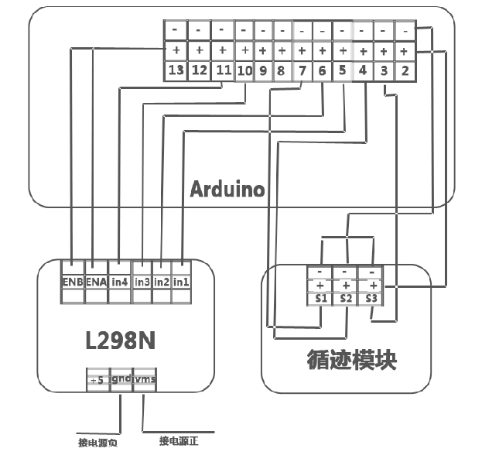<!--[if !vml]--> <!--[endif]-->

循迹小车 Arduino 程序： Tracking car Arduino program:

int MotorRight1=5; int MotorRight1 = 5;

int MotorRight2=6; int MotorRight2 = 6;

int MotorLeft1=10; int MotorLeft1 = 10;

int MotorLeft2=11; int MotorLeft2 = 11;

const int SensorLeft = 7; const int SensorLeft = 7; // 左感測器輸入腳 / / Left sensor input pin

const int SensorMiddle= 4 ; const int SensorMiddle = 4; // 中感測器輸入腳 / / The sensor input pin

const int SensorRight = 3; const int SensorRight = 3; // 右感測器輸入腳 / / Right sensor input pin

int SL; int SL; // 左感測器狀態 / / Left sensor status

int SM; int SM; // 中感測器狀態 / / The sensor status

int SR; int SR; // 右感測器狀態 / / Right sensor status

void setup() void setup ()

{ {

Serial.begin( 9600); Serial.begin (9600);

pinMode(MotorRight1, OUTPUT); pinMode (MotorRight1, OUTPUT); // 腳位 8 (PWM) / / Pin 8 (PWM)

pinMode(MotorRight2, OUTPUT); pinMode (MotorRight2, OUTPUT); // 腳位 9 (PWM) / / Pin 9 (PWM)

pinMode(MotorLeft1, pinMode (MotorLeft1, OUTPUT); OUTPUT); // 腳位 10 (PWM) / / Pin 10 (PWM)

pinMode(MotorLeft2, pinMode (MotorLeft2, OUTPUT); OUTPUT); // 腳位 11 (PWM) / / Pin 11 (PWM)

pinMode(SensorLeft, INPUT); // 定義左感測器 pinMode (SensorLeft, INPUT); / / define left Sensors

pinMode(SensorMiddle, INPUT);// 定義中感測器 pinMode (SensorMiddle, INPUT) ;/ / definition sensors

pinMode(SensorRight, INPUT); // 定義右感測器 pinMode (SensorRight, INPUT); / / definition of the right sensor

} }

void loop() void loop ()

{ {

SL = digitalRead( SensorLeft); SL = digitalRead (SensorLeft);

SM = digitalRead( SensorMiddle); SM = digitalRead (SensorMiddle);

SR = digitalRead( SensorRight); SR = digitalRead (SensorRight);

if (SM == HIGH)// 中感測器在黑色區域 if (SM == HIGH) / / in sensors in black areas

{ {

if (SL == LOW & SR == HIGH) // 左黑右白 , 向左轉彎 if (SL == LOW & SR == HIGH) / / left and right black white, turn left

{ {

digitalWrite( MotorRight1,LOW); digitalWrite (MotorRight1, LOW);

digitalWrite( MotorRight2,HIGH); digitalWrite (MotorRight2, HIGH);

analogWrite( MotorLeft1,0); analogWrite (MotorLeft1, 0);

analogWrite( MotorLeft2,80); analogWrite (MotorLeft2, 80);

} }

else if (SR == LOW & SL == HIGH) // 左白右黑 , 向右轉彎 else if (SR == LOW & SL == HIGH) / / left and right black white, turn right

{ {

analogWrite(MotorRight1,0);// 右轉 analogWrite (MotorRight1, 0) ;/ / right turn

analogWrite( MotorRight2,80); analogWrite (MotorRight2, 80);

digitalWrite( MotorLeft1,LOW); digitalWrite (MotorLeft1, LOW);

digitalWrite( MotorLeft2,HIGH); digitalWrite (MotorLeft2, HIGH);

} }

else else // 兩側 均為白色 , 直進 / / Both sides white, straight

{ {

digitalWrite( MotorRight1,LOW); digitalWrite (MotorRight1, LOW);

digitalWrite( MotorRight2,HIGH); digitalWrite (MotorRight2, HIGH);

digitalWrite( MotorLeft1,LOW); digitalWrite (MotorLeft1, LOW);

digitalWrite( MotorLeft2,HIGH); digitalWrite (MotorLeft2, HIGH);

analogWrite( MotorLeft1,200); analogWrite (MotorLeft1, 200);

analogWrite( MotorLeft2,200); analogWrite (MotorLeft2, 200);

analogWrite( MotorRight1,200); analogWrite (MotorRight1, 200);

analogWrite( MotorRight2,200); analogWrite (MotorRight2, 200);

} }

} }

else // 中感測器在白色區域 else / / the sensors in the white area

{ {

if (SL == LOW & SR == HIGH)// 左黑右白 , 快速左轉 if (SL == LOW & SR == HIGH) / / left and right black white, fast turn left

{ {

digitalWrite( MotorRight1,LOW); digitalWrite (MotorRight1, LOW);

digitalWrite( MotorRight2,HIGH); digitalWrite (MotorRight2, HIGH);

digitalWrite( MotorLeft1,LOW); digitalWrite (MotorLeft1, LOW);

digitalWrite( MotorLeft2,LOW); digitalWrite (MotorLeft2, LOW);

} }

else if (SR == LOW & SL == HIGH) // 左白右黑 , 快速右轉 else if (SR == LOW & SL == HIGH) / / left and right black white, quick right turn

{ {

digitalWrite( MotorRight1,LOW); digitalWrite (MotorRight1, LOW);

digitalWrite( MotorRight2,LOW); digitalWrite (MotorRight2, LOW);

digitalWrite( MotorLeft1,LOW); digitalWrite (MotorLeft1, LOW);

digitalWrite( MotorLeft2,HIGH); digitalWrite (MotorLeft2, HIGH);

} }

else // 都是白色 , 停止 else / / are white, stop

{ {

digitalWrite( MotorRight1,HIGH); digitalWrite (MotorRight1, HIGH);

digitalWrite( MotorRight2,LOW); digitalWrite (MotorRight2, LOW);

digitalWrite( MotorLeft1,HIGH); digitalWrite (MotorLeft1, HIGH);

digitalWrite( MotorLeft2,LOW);; digitalWrite (MotorLeft2, LOW);;

}}} }}}

**3. 超声波避障智能车** **3 ultrasonic obstacle avoidance Smart Car**

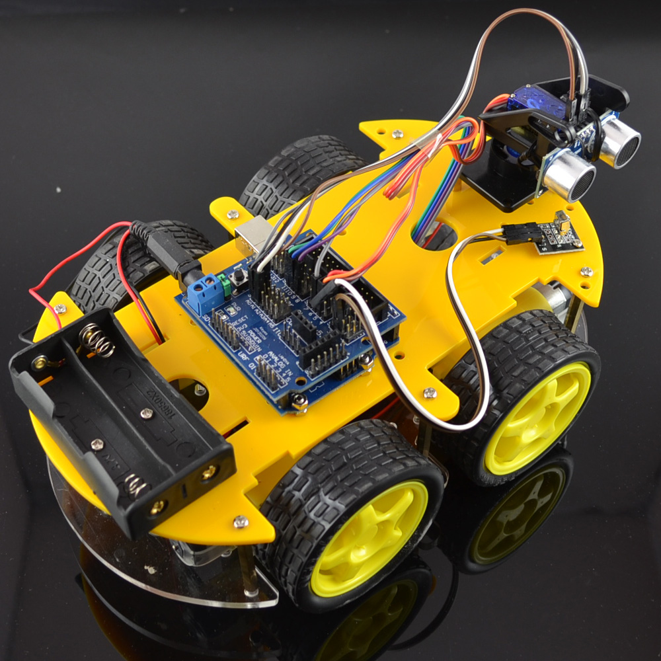<!--[if !vml]--> <!--[endif]-->

超声波智能避障实现方便、计算简单、易于做到实时控制 , 并且在测量精度方面能达到实用的要求 , 因此成为常用的避障方法。 Ultrasonic Intelligent obstacle avoidance achieve convenient computing simple, easy to do real-time control, and measurement accuracy can meet the practical requirements, it became common obstacle avoidance. 超声波使用方法参考（ Arduino 超声波测距说明）。 Ultrasonic use reference (Arduino Ultrasonic Ranging instructions).

超声波智能接线图； Ultrasonic intelligent wiring diagram;

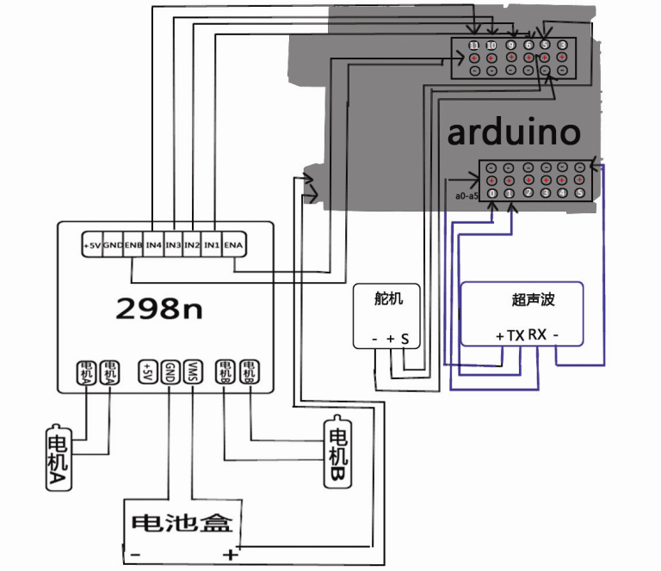<!--[if !vml]--> <!--[endif]-->

一 ：电机的连线 A: Motor connection

电机一接 L298N 的 MOTOA L298N motor a pick of MOTOA

电机二接 L298N 的 MOTOB The two then L298N motor MOTOB

二： L298N 的供电处理 Two: L298N supply deal

用 6 节 5 号电池盒取一路电源给 L298N 电机驱动模块供电，另一路给 ARDUINO 主板供电， 5 with 6 way power to the battery box to take L298N motor drive module power, the other way to ARDUINO board power supply,

给 L298N 电机驱动模块供电的电源 + 极接 L298N 的 VMS 接口，电源的 - 接 L298N 的 GND 接口， L298N 板上的 +5V 接口放空不接。 L298N motor drive module to the power supply + pole to L298N of VMS interface power - L298N the GND connection interfaces, +5 V Interface L298N vent panel is not connected.

<!--[if !vml]--> <!--[endif]-->

三：电机的使能和转向（配合程序） Three: the motor and steering enabled (with the program)

int pinLB=6; int pinLB = 6; // 定義 6 腳位 左後 ，接给力板 PWM6 脚 / / After defining the 6 pin left, then to the foot force plate PWM6

int pinLF=9; int pinLF = 9; // 定義 9 腳位 左前，接给力板 PWM9 脚 / / Define the 9 pin left, then to the foot force plate PWM9

int pinRB=10; int pinRB = 10; // 定義 10 腳位右後 ，接给力板 PWM10 脚 / / Define pin 10 right rear, then to force the foot plate PWM10

int pinRF=11; int pinRF = 11; // 定義 11 腳位右前，接给力板 PWM11 脚 / / Define the 11-pin front right, then to the foot force plate PWM11

四：舵机的连线 Four: Servo connections

myservo.attach(5); myservo.attach (5); // 定義伺服馬達輸出第 5 腳位 (PWM) / / Define servo motor output section 5 pin (PWM)

五：超声波传感器的连线 Five: ultrasonic sensor connection

超声波传感器有四个脚 Ultrasonic sensors have four legs

VCC 接 +5V VCC +5 V connection

TRIQ 信号输入 TRIQ signal input

ECHO 信号输出 ECHO signal output

GND 接地 GND Ground

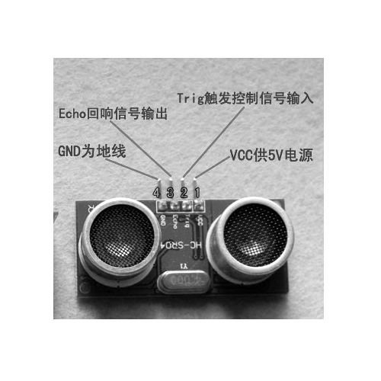<!--[if !vml]--> <!--[endif]-->

int inputPin = A0; int inputPin = A0; // 定義超音波信號接收腳位 / / Define pin ultrasonic signal reception

int outputPin =A1; int outputPin = A1; // 定義超音波信號發射腳位 / / Define pin ultrasonic signal transmitter

超声波智能避障车程序（ ARDUINO ） Ultrasonic Smart car obstacle avoidance procedures (ARDUINO)

L = 左 L = Left

R = 右 R = Right

F = 前 F = front

B = 後 B = after

*/ * /

#include <Servo.h> # Include <Servo.h>

int pinLB=6; int pinLB = 6; // 定義 6 腳位 左後 / / Define pin left after 6

int pinLF=9; int pinLF = 9; // 定義 9 腳位 左前 / / Define the 9-pin front left

int pinRB=10; int pinRB = 10; // 定義 10 腳位 右後 / 10 pin definitions right rear /

int pinRF=11; int pinRF = 11; // 定義 11 腳位 右前 / / Define the 11-pin front right

int inputPin = A0; int inputPin = A0; // 定義超音波信號接收腳位 / / Define pin ultrasonic signal reception

int outputPin =A1; int outputPin = A1; // 定義超音波信號發射腳位 / / Define pin ultrasonic signal transmitter

int Fspeedd = 0; int Fspeedd = 0; // 前速 / /-Speed

int Rspeedd = 0; int Rspeedd = 0; // 右速 / / Right speed

int Lspeedd = 0; int Lspeedd = 0; // 左速 / / Left-speed

int directionn = 0; int directionn = 0; // 前 =8 後 =2 左 =4 右 =6 / / Front Left = 8 after = 2 = 4 Right = 6

Servo myservo; Servo myservo; // 設 myservo / / Set myservo

int delay_time = 250; // 伺服馬達轉向後的穩定時間 int delay_time = 250; / / settling time after steering servo motors

int Fgo = 8; int Fgo = 8; // 前進 / / Forward

int Rgo = 6; int Rgo = 6; // 右轉 / / Right

int Lgo = 4; int Lgo = 4; // 左轉 / / Left

int Bgo = 2; int Bgo = 2; // 倒車 / / Reverse

void setup() void setup ()

{ {

Serial.begin(9600); Serial.begin (9600); // 定義馬達輸出腳位 / / Define motor output pin

pinMode(pinLB,OUTPUT); // 腳位 8 (PWM) pinMode (pinLB, OUTPUT); / / pin 8 (PWM)

pinMode(pinLF,OUTPUT); // 腳位 9 (PWM) pinMode (pinLF, OUTPUT); / / pin 9 (PWM)

pinMode(pinRB,OUTPUT); // 腳位 10 (PWM) pinMode (pinRB, OUTPUT); / / pin 10 (PWM)

pinMode(pinRF,OUTPUT); // 腳位 11 (PWM) pinMode (pinRF, OUTPUT); / / pin 11 (PWM)

pinMode(inputPin, INPUT); pinMode (inputPin, INPUT); // 定義超音波輸入腳位 / / Define ultrasound input pin

pinMode(outputPin, OUTPUT); pinMode (outputPin, OUTPUT); // 定義超音波輸出腳位 / / Define ultrasonic output pin

myservo.attach(5); myservo.attach (5); // 定義伺服馬達輸出第 5 腳位 (PWM) / / Define servo motor output section 5 pin (PWM)

} }

void advance(int a) void advance (int a) // 前進 / / Forward

{ {

digitalWrite(pinRB,LOW); digitalWrite (pinRB, LOW); // 使馬達（右後 ） 動作 / / The motor (rear right) action

digitalWrite( pinRF,HIGH); digitalWrite (pinRF, HIGH);

digitalWrite(pinLB,LOW); digitalWrite (pinLB, LOW); // 使馬達（左後 ） 動作 / / The motor (left rear) action

digitalWrite( pinLF,HIGH); digitalWrite (pinLF, HIGH);

delay( a * 100); delay (a * 100);

} }

void right(int b) void right (int b) // 右轉 ( 單 輪 ) / / Turn right (single wheel)

{ {

digitalWrite(pinRB,LOW); digitalWrite (pinRB, LOW); // 使馬達（右後 ） 動作 / / The motor (rear right) action

digitalWrite( pinRF,HIGH); digitalWrite (pinRF, HIGH);

digitalWrite( pinLB,HIGH); digitalWrite (pinLB, HIGH);

digitalWrite( pinLF,HIGH); digitalWrite (pinLF, HIGH);

delay( b * 100); delay (b * 100);

} }

void left(int c) void left (int c) // 左轉 ( 單 輪 ) / / Turn left (single wheel)

{ {

digitalWrite( pinRB,HIGH); digitalWrite (pinRB, HIGH);

digitalWrite( pinRF,HIGH); digitalWrite (pinRF, HIGH);

digitalWrite(pinLB,LOW); digitalWrite (pinLB, LOW); // 使馬達（左後 ） 動作 / / The motor (left rear) action

digitalWrite( pinLF,HIGH); digitalWrite (pinLF, HIGH);

delay( c * 100); delay (c * 100);

} }

void turnR(int d) void turnR (int d) // 右轉 ( 雙輪 ) / / Turn right (wheel)

{ {

digitalWrite(pinRB,LOW); digitalWrite (pinRB, LOW); // 使馬達（右後 ） 動作 / / The motor (rear right) action

digitalWrite( pinRF,HIGH); digitalWrite (pinRF, HIGH);

digitalWrite( pinLB,HIGH); digitalWrite (pinLB, HIGH);

digitalWrite(pinLF,LOW); digitalWrite (pinLF, LOW); // 使馬達（左前） 動作 / / The motor (front left) action

delay( d * 100); delay (d * 100);

} }

void turnL(int e) void turnL (int e) // 左轉 ( 雙輪 ) / / Turn left (wheel)

{ {

digitalWrite( pinRB,HIGH); digitalWrite (pinRB, HIGH);

digitalWrite(pinRF,LOW); digitalWrite (pinRF, LOW); // 使馬達（右前） 動作 / / The motor (front right) action

digitalWrite(pinLB,LOW); digitalWrite (pinLB, LOW); // 使馬達（左後 ） 動作 / / The motor (left rear) action

digitalWrite( pinLF,HIGH); digitalWrite (pinLF, HIGH);

delay( e * 100); delay (e * 100);

} }

void stopp(int f) void stopp (int f) // 停止 / / Stop

{ {

digitalWrite( pinRB,HIGH); digitalWrite (pinRB, HIGH);

digitalWrite( pinRF,HIGH); digitalWrite (pinRF, HIGH);

digitalWrite( pinLB,HIGH); digitalWrite (pinLB, HIGH);

digitalWrite( pinLF,HIGH); digitalWrite (pinLF, HIGH);

delay( f * 100); delay (f * 100);

} }

void back(int g) void back (int g) // 後 退 / / Check out

{ {

digitalWrite(pinRB,HIGH); digitalWrite (pinRB, HIGH); // 使馬達（右後 ） 動作 / / The motor (rear right) action

digitalWrite( pinRF,LOW); digitalWrite (pinRF, LOW);

digitalWrite(pinLB,HIGH); digitalWrite (pinLB, HIGH); // 使馬達（左後 ） 動作 / / The motor (left rear) action

digitalWrite( pinLF,LOW); digitalWrite (pinLF, LOW);

delay( g * 100); delay (g * 100);

} }

void detection() void detection () // 測量 3 個角度 (0.90.179) / / Measure three angles (0.90.179)

{ {

int delay_time = 250; int delay_time = 250; // 伺服馬達轉向後的穩定時間 Settling time / / servo motor after turning

ask_pin_F(); ask_pin_F (); // 讀取前方距離 / / Read from front

if(Fspeedd < 10) if (Fspeedd <10) // 假如前方距離小於 10 公分 / / If the distance is less than 10 cm in front of

{ {

stopp(1); stopp (1); // 清除輸出資料 / / Clear the output data

back(2); back (2); // 後 退 0.2 秒 / / Check out 0.2 seconds

} }

if(Fspeedd < 25) if (Fspeedd <25) // 假如前方距離小於 25 公分 / / If the distance is less than 25 cm in front of

{ {

stopp(1); stopp (1); // 清除輸出資料 / / Clear the output data

ask_pin_L(); ask_pin_L (); // 讀取左方距離 / / Read from left

delay(delay_time); delay (delay_time); // 等待伺服馬達穩定 / / Wait for a stable servo motor

ask_pin_R(); ask_pin_R (); // 讀取右方距離 / / Read from the right

delay(delay_time); delay (delay_time); // 等待伺服馬達穩定 / / Wait for a stable servo motor

if(Lspeedd > Rspeedd) if (Lspeedd> Rspeedd) // 假如 左邊距離大於右邊距離 / / If the distance is greater than the right from the left

{ {

directionn = Rgo; directionn = Rgo; // 向右走 / / Right away

} }

if(Lspeedd <= Rspeedd) if (Lspeedd <= Rspeedd) // 假如 左邊距離小於或等於右邊距離 / / If the left is less than or equal to the distance from the right

{ {

directionn = Lgo; directionn = Lgo; // 向左走 / / Turn Left

} }

if (Lspeedd < 10 && Rspeedd < 10) if (Lspeedd <10 && Rspeedd <10) // 假如 左邊距離和右邊距離皆小於 10 公分 / / If the distance to the left and right are less than 10 cm distance

{ {

directionn = Bgo; directionn = Bgo; // 向後走 / / To go after

} }

} }

else else // 加如前方不小於 ( 大於 )25 公分 / / Add as front not less than (greater than) 25 cm

{ {

directionn = Fgo; directionn = Fgo; // 向前走 / / Move forward

} }

} }

void ask_pin_F() void ask_pin_F () // 量出前方距離 / / Measure the distance from the front

{ {

myservo.write( 90); myservo.write (90);

digitalWrite(outputPin, LOW); digitalWrite (outputPin, LOW); // 讓超聲波發射低電壓 2 μ s / / Let ultrasonic transmitter low voltage 2 μ s

delayMicroseconds( 2); delayMicroseconds (2);

digitalWrite(outputPin, HIGH); digitalWrite (outputPin, HIGH); // 讓超聲波發射高電壓 10 μ s ，這裡至少是 10 μ s / / Let ultrasonic transmitter high voltage 10 μ s, where at least 10 μ s

delayMicroseconds( 10); delayMicroseconds (10);

digitalWrite(outputPin, LOW); digitalWrite (outputPin, LOW); // 維持超聲波發射低電壓 / / Maintain low voltage ultrasonic transmitter

float Fdistance = pulseIn(inputPin, HIGH); float Fdistance = pulseIn (inputPin, HIGH); // 讀差相差時間 / / Read worse time difference

Fdistance= Fdistance/5.8/10; Fdistance = Fdistance/5.8/10; // 將 時間轉為距離距离（ 單位：公分） / / Time to turn to the distance (unit: cm)

Serial.print("F distance:"); Serial.print ("F distance:"); // 輸出距離（ 單位：公分） / / Output distance (unit: cm)

Serial.println(Fdistance); Serial.println (Fdistance); // 顯示距離 / / Display the distance

Fspeedd = Fdistance; Fspeedd = Fdistance; // 將 距離 讀入 Fspeedd( 前速 ) / / Read into the distance Fspeedd (former speed)

} }

void ask_pin_L() void ask_pin_L () // 量出左邊距離 / / Measure the distance from the left

{ {

myservo.write( 5); myservo.write (5);

delay( delay_time); delay (delay_time);

digitalWrite(outputPin, LOW); digitalWrite (outputPin, LOW); // 讓超聲波發射低電壓 2 μ s / / Let ultrasonic transmitter low voltage 2 μ s

delayMicroseconds( 2); delayMicroseconds (2);

digitalWrite(outputPin, HIGH); digitalWrite (outputPin, HIGH); // 讓超聲波發射高電壓 10 μ s ，這裡至少是 10 μ s / / Let ultrasonic transmitter high voltage 10 μ s, where at least 10 μ s

delayMicroseconds( 10); delayMicroseconds (10);

digitalWrite(outputPin, LOW); digitalWrite (outputPin, LOW); // 維持超聲波發射低電壓 / / Maintain low voltage ultrasonic transmitter

float Ldistance = pulseIn(inputPin, HIGH); float Ldistance = pulseIn (inputPin, HIGH); // 讀差相差時間 / / Read worse time difference

Ldistance= Ldistance/5.8/10; Ldistance = Ldistance/5.8/10; // 將 時間轉為距離距离（ 單位：公分） / / Time to turn to the distance (unit: cm)

Serial.print("L distance:"); Serial.print ("L distance:"); // 輸出距離（ 單位：公分） / / Output distance (unit: cm)

Serial.println(Ldistance); Serial.println (Ldistance); // 顯示距離 / / Display the distance

Lspeedd = Ldistance; Lspeedd = Ldistance; // 將 距離 讀入 Lspeedd( 左速 ) / / Read into the distance Lspeedd (left-speed)

} }

void ask_pin_R() void ask_pin_R () // 量出右邊距離 / / Measure the distance from the right

{ {

myservo.write( 177); myservo.write (177);

delay( delay_time); delay (delay_time);

digitalWrite(outputPin, LOW); digitalWrite (outputPin, LOW); // 讓超聲波發射低電壓 2 μ s / / Let ultrasonic transmitter low voltage 2 μ s

delayMicroseconds( 2); delayMicroseconds (2);

digitalWrite(outputPin, HIGH); digitalWrite (outputPin, HIGH); // 讓超聲波發射高電壓 10 μ s ，這裡至少是 10 μ s / / Let ultrasonic transmitter high voltage 10 μ s, where at least 10 μ s

delayMicroseconds( 10); delayMicroseconds (10);

digitalWrite(outputPin, LOW); digitalWrite (outputPin, LOW); // 維持超聲波發射低電壓 / / Maintain low voltage ultrasonic transmitter

float Rdistance = pulseIn(inputPin, HIGH); float Rdistance = pulseIn (inputPin, HIGH); // 讀差相差時間 / / Read worse time difference

Rdistance= Rdistance/5.8/10; Rdistance = Rdistance/5.8/10; // 將 時間轉為距離距离（ 單位：公分） / / Time to turn to the distance (unit: cm)

Serial.print("R distance:"); Serial.print ("R distance:"); // 輸出距離（ 單位：公分） / / Output distance (unit: cm)

Serial.println(Rdistance); Serial.println (Rdistance); // 顯示距離 / / Display the distance

Rspeedd = Rdistance; Rspeedd = Rdistance; // 將 距離 讀入 Rspeedd( 右速 ) / / Will read into the distance Rspeedd (Right-speed)

} }

void loop() void loop ()

{ {

myservo.write(90); myservo.write (90); // 讓伺服馬達回歸 預備位置準備 下一次的測量 / / Let servo motor position ready to return to the pre-prepared next time measurement

detection(); detection (); // 測量角度 並且判斷要往哪一方向移動 / / Measure the angle and direction of judgment to where to move

if(directionn == 2) if (directionn == 2) // 假如 directionn( 方向 ) = 2( 倒車 ) / / If directionn (direction) = 2 (reverse)

{ {

back(8); back (8); // / / 倒退 ( 車 ) Retrogression (car)

turnL(2); turnL (2); // 些微向左方移動 ( 防止卡在死巷裡 ) / / Move slightly to the left (to prevent stuck in dead alley)

Serial.print(" Reverse "); Serial.print ("Reverse"); // 顯示方向 ( 倒退 ) / / Display direction (backwards)

} }

if(directionn == 6) if (directionn == 6) // 假如 directionn( 方向 ) = 6( 右轉 ) / / If directionn (direction) = 6 (right turn)

{ {

back( 1); back (1);

turnR(6); turnR (6); // 右轉 / / Right

Serial.print(" Right "); Serial.print ("Right"); // 顯示方向 ( 左轉 ) / / Display direction (turn left)

} }

if(directionn == 4) if (directionn == 4) // 假如 directionn( 方向 ) = 4( 左轉 ) / / If directionn (direction) = 4 (turn left)

{ {

back( 1); back (1);

turnL(6); turnL (6); // 左轉 / / Left

Serial.print(" Left "); Serial.print ("Left"); // 顯示方向 ( 右轉 ) / / Display direction (turn right)

} }

if(directionn == 8) if (directionn == 8) // 假如 directionn( 方向 ) = 8( 前進 ) / / If directionn (direction) = 8 (forward)

{ {

advance(1); advance (1); // 正常前進 / / Normal Forward

Serial.print(" Advance "); Serial.print ("Advance"); // 顯示方向 ( 前進 ) / / Display direction (forward)

Serial.print( " Serial.print (" "); ");

} }

} }

**4. 红外遥控智能车实验** **4 infrared remote intelligent vehicle test**

实验前须知： Experiment before you go:

1. 先把 IRremote 函式库 资料夹放进 Arduino libraries 目录底下 1 first IRremote library folders into libraries directory under Arduino

2. 开启 IrReceive.pde 测得自己的红外线遥控的码（在 Serial Monitor 可显示 IRcode ），再将 IRcode 记录下来，然后到程式里面修改成自己的红外线码即可 。 2 open IrReceive.pde measured their infrared remote control code (in the Serial Monitor can display IRcode), then IRcode record, and then to revise their programs which can be infrared codes.

/* / *

* IRRemote 红外遥控码测试 * IRRemote infrared remote control code test

* * 範例 1.2: 顯示紅外線協定種類，如 NEC, Sony SIRC, Philips RC5, Philips RC6 等協定 Examples 1.2: Show infrared protocol type, such as NEC, Sony SIRC, Philips RC5, Philips RC6 and other agreements

*/ * /

#include <IRremote.h> # Include <IRremote.h> // 引用 IRRemote 函式庫 / / Function library references IRRemote

const int irReceiverPin = 2; const int irReceiverPin = 2; // 紅外線接收器 OUTPUT 訊號接在 pin 2 / / OUTPUT signals IR receiver connected to pin 2

IRrecv irrecv(irReceiverPin); IRrecv irrecv (irReceiverPin); // 定義 IRrecv 物件來接收紅外線訊號 / / Define an object to receive infrared signals IRrecv

decode_results results; decode_results results; // 解碼結果將放在 decode_results 結構的 result 變數裏 / / Decoding results will result in structural variables in decode_results

void setup() void setup ()

{ {

Serial.begin(9600); Serial.begin (9600); // 開啟 Serial port, 通訊速率為 9600 bps / / Open Serial port, the communication speed is 9600 bps

irrecv.enableIRIn(); irrecv.enableIRIn (); // 啟動 紅外線解碼 / / Start infrared decoding

} }

// 顯示紅外線協定種類 / / Display the type of infrared protocol

void showIRProtocol(decode_results *results) void showIRProtocol (decode_results * results)

{ {

Serial.print( "Protocol: "); Serial.print ("Protocol:");

// 判斷紅外線協定種類 / / Judgment infrared protocol types

switch( results->decode_type) { switch (results-> decode_type) {

case NEC: case NEC:

Serial.print( "NEC"); Serial.print ("NEC");

break ; break;

case SONY: case SONY:

Serial.print( "SONY"); Serial.print ("SONY");

break ; break;

case RC5: case RC5:

Serial.print( "RC5"); Serial.print ("RC5");

break ; break;

case RC6: case RC6:

Serial.print( "RC6"); Serial.print ("RC6");

break ; break;

default : default:

Serial.print( "Unknown encoding"); Serial.print ("Unknown encoding");

} }

// 把紅外線編碼印到 Serial port / / Print the infrared codes to Serial port

Serial.print( ", irCode: "); Serial.print (", irCode:");

Serial.print(results->value, HEX); Serial.print (results-> value, HEX); // 紅外線編碼 / / Infrared code

Serial.print( ", Serial.print (", bits: "); bits: ");

Serial.println(results->bits); Serial.println (results-> bits); // 紅外線編碼位元數 / / Number of bits coded infrared

} }

void loop() void loop ()

{ {

if (irrecv.decode(&results)) { if (irrecv.decode (& results)) { // 解碼成功，收到一組紅外線訊號 / / Decoding is successful, you receive a set of infrared signals

showIRProtocol(&results); showIRProtocol (& results); // 顯示紅外線協定種類 / / Display the type of infrared protocol

irrecv.resume(); irrecv.resume (); // 繼續收下一組紅外線訊號 / / Continue to accept a set of infrared signals

} }

} }

把测到的红外键值码，替换到程序中红外控制的部分 The measured infrared key code into the program to replace the infrared part of the control

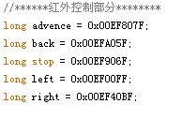<!--[if !vml]--> <!--[endif]-->

红外遥控智能车程序 Infrared remote intelligent vehicle program

//****** 红外遥控智能车程序 ******* / / ****** Infrared remote intelligent vehicle program *******

#include <IRremote.h> # Include <IRremote.h>

int RECV_PIN = A0; int RECV_PIN = A0;

int pinLB=6;// 定义 I1 接口 int pinLB = 6 ;/ / define interfaces I1

int pinLF=9;// 定义 I2 接口 int pinLF = 9 ;/ / define I2 interfaces

int pinRB=3;// 定义 I3 接口 int pinRB = 3 ;/ / define I3 Interface

int pinRF=5;// 定义 I4 接口 int pinRF = 5 ;/ / define I4 Interface

//****** 红外控制部分 ******** / / ****** Infrared control section ********

long advence = 0x00EF long advence = 0x00EF 807F 807F ; ;

long back = 0x00EFA long back = 0x00EFA 05F 05F ; ;

long stop = 0x00EF long stop = 0x00EF 906F 906F ; ;

long left = 0x00EF00FF; long left = 0x00EF00FF;

long right = 0x00EF40BF; long right = 0x00EF40BF;

IRrecv irrecv( RECV_PIN); IRrecv irrecv (RECV_PIN);

decode_results results; decode_results results;

void dump(decode_results *results) { void dump (decode_results * results) {

int count = results->rawlen; int count = results-> rawlen;

if (results->decode_type == UNKNOWN) if (results-> decode_type == UNKNOWN)

{ {

Serial.println( "Could not decode message"); Serial.println ("Could not decode message");

} }

else else

{ {

if (results->decode_type == NEC) if (results-> decode_type == NEC)

{ {

Serial.print( "Decoded NEC: "); Serial.print ("Decoded NEC:");

} }

else if (results->decode_type == SONY) else if (results-> decode_type == SONY)

{ {

Serial.print( "Decoded SONY: "); Serial.print ("Decoded SONY:");

} }

else if (results->decode_type == RC5) else if (results-> decode_type == RC5)

{ {

Serial.print( "Decoded RC5: "); Serial.print ("Decoded RC5:");

} }

else if (results->decode_type == RC6) else if (results-> decode_type == RC6)

{ {

Serial.print( "Decoded RC6: "); Serial.print ("Decoded RC6:");

} }

Serial.print( results->value, HEX); Serial.print (results-> value, HEX);

Serial.print( " ("); Serial.print ("(");

Serial.print( results->bits, DEC); Serial.print (results-> bits, DEC);

Serial.println( " bits)"); Serial.println ("bits)");

} }

Serial.print( "Raw ("); Serial.print ("Raw (");

Serial.print( count, DEC); Serial.print (count, DEC);

Serial.print( "): "); Serial.print ("):");

for (int i = 0; i < count; i++) for (int i = 0; i <count; i + +)

{ {

if ((i % 2) == 1) { if ((i% 2) == 1) {

Serial.print( results->rawbuf[i]*USECPERTICK, DEC); Serial.print (results-> rawbuf [i] * USECPERTICK, DEC);

} }

else else

{ {

Serial.print( -(int)results->rawbuf[i]*USECPERTICK, DEC); Serial.print (- (int) results-> rawbuf [i] * USECPERTICK, DEC);

} }

Serial.print( " "); Serial.print ("");

} }

Serial.println( ""); Serial.println ("");

} }

void setup() void setup ()

{ {

pinMode( RECV_PIN, INPUT); pinMode (RECV_PIN, INPUT);

pinMode( pinLB,OUTPUT); pinMode (pinLB, OUTPUT);

pinMode( pinLF,OUTPUT); pinMode (pinLF, OUTPUT);

pinMode( pinRB,OUTPUT); pinMode (pinRB, OUTPUT);

pinMode( pinRF,OUTPUT); pinMode (pinRF, OUTPUT);

Serial.begin( 9600); Serial.begin (9600);

irrecv.enableIRIn( ); // Start the receiver irrecv.enableIRIn (); / / Start the receiver

} }

int on = 0; int on = 0;

unsigned long last = millis(); unsigned long last = millis ();

void loop() void loop ()

{ {

if (irrecv.decode(&results)) if (irrecv.decode (& results))

{ {

// If it's been at least 1/4 second since the last / / If it's been at least 1/4 second since the last

// IR received, toggle the relay / / IR received, toggle the relay

if (millis() - last > 250) if (millis () - last> 250)

{ {

on = !on; on = on!;

// / / digitalWrite( 8, on ? HIGH : LOW); digitalWrite (8, on HIGH:? LOW);

digitalWrite( 13, on ? HIGH : LOW); digitalWrite (13, on HIGH:? LOW);

dump( &results); dump (& results);

} }

if (results.value == advence ) if (results.value == advence)

{digitalWrite(pinRB,LOW);// 使直流电机（右） GO {DigitalWrite (pinRB, LOW) ;/ / make DC motor (right) GO

digitalWrite( pinRF,HIGH); digitalWrite (pinRF, HIGH);

digitalWrite(pinLB,LOW);// 使直流电机（左） GO digitalWrite (pinLB, LOW) ;/ / make DC motor (left) GO

digitalWrite( pinLF,HIGH);} digitalWrite (pinLF, HIGH);}

if (results.value == back ) if (results.value == back)

{digitalWrite(pinRB,HIGH);// 使直流电机（右） BACK {DigitalWrite (pinRB, HIGH) ;/ / make DC motor (right) BACK

digitalWrite( pinRF,LOW);} digitalWrite (pinRF, LOW);}

if (results.value == left ) if (results.value == left)

{ digitalWrite(pinRB,LOW);// 使直流电机（右） STOP {DigitalWrite (pinRB, LOW) ;/ / make DC motor (right) STOP

digitalWrite( pinRF,HIGH); digitalWrite (pinRF, HIGH);

digitalWrite(pinLB,HIGH);// 使直流电机（左） GO digitalWrite (pinLB, HIGH) ;/ / make DC motor (left) GO

digitalWrite( pinLF,LOW);} digitalWrite (pinLF, LOW);}

if (results.value == right ) if (results.value == right)

{ digitalWrite(pinRB,HIGH);// 使直流电机（右） GO {DigitalWrite (pinRB, HIGH) ;/ / make DC motor (right) GO

digitalWrite( pinRF,LOW); digitalWrite (pinRF, LOW);

digitalWrite(pinLB,HIGH);// 使直流电机（左） STOP digitalWrite (pinLB, HIGH) ;/ / make DC motor (left) STOP

digitalWrite( pinLF,HIGH);} digitalWrite (pinLF, HIGH);}

if (results.value == stop ) if (results.value == stop)

{ {

digitalWrite(pinRB,HIGH);// 使直流电机（右） STOP digitalWrite (pinRB, HIGH) ;/ / make DC motor (right) STOP

digitalWrite( pinRF,HIGH); digitalWrite (pinRF, HIGH);

digitalWrite(pinLB,HIGH);// 使直流电机（左） STOP digitalWrite (pinLB, HIGH) ;/ / make DC motor (left) STOP

digitalWrite( pinLF,HIGH); digitalWrite (pinLF, HIGH);

} }

last = millis(); last = millis ();

irrecv.resume( ); // Receive the next value irrecv.resume (); / / Receive the next value

} }

} }

**5. 手机控制蓝牙智能车** **5 Smart Car Bluetooth phone control**

Arduino 通过蓝牙通信 Arduino via Bluetooth communication

<!--[if !vml]--> <!--[endif]--><!--[if !vml]--> <!--[endif]--> 蓝牙 — - 这个名称来自于第十世纪的一位丹麦国王 Harald Blatand , Blatand 在英文里的意思可以被解释为 Bluetooth( 蓝牙 ) 。 Bluetooth - This name came from a tenth-century Danish King Harald Blatand, Blatand meaning in the English language can be interpreted as Bluetooth (Bluetooth).

    所谓蓝牙 (Bluetooth) 技术，实际上是一种短距离无线电技术，利用 “ 蓝牙 ” 技术，能够有效地简化掌上电脑、笔记本电脑和移动电话手机等移动通信终端设备之间的通信，也能够成功地简化以上这些设备与因特网（ Internet ）之间的通信，从而使这些现代通信设备与因特网之间的数据传输变得更加迅速高效，为无线通信拓宽道路。 The so-called Bluetooth (Bluetooth) technology, in fact, is a short-range radio technology, the use of "Bluetooth" technology that can effectively simplify PDAs, notebook computers and communications mobile phone handsets and other mobile communications terminal equipment, but also able to successfully These simplify the communication device and the Internet (Internet) between them so that the modern data transmission between the communication device and the Internet more quickly and efficiently, to broaden the wireless communication path.

       因为是初次与蓝牙模块打交道，今天还是先来小试牛刀，让 Arduino 与 pc 机成功通信吧。 Because it is the first to deal with the Bluetooth module, today or take a small test chopper, make Arduino and pc successfully communicate it. 先来接线，主板 +5V 连接蓝牙 VCC ，主板 GND 连接蓝牙 -GND ，主板 TX 连接蓝牙 RX ， RX 连接蓝牙 TX 。 Let's wiring, the board +5 V connection Bluetooth VCC, GND motherboard connector Bluetooth-GND, TX motherboard connection Bluetooth RX, RX connected Bluetooth TX. 当蓝牙模块成功的与 PC 机连接电源后， 蓝牙模块电源指示灯会闪烁，连接指示灯绿灯会点亮。 After the success of the Bluetooth module connected to the power supply and PC, Bluetooth module power indicator flashes green link light is lit.

    下面就来看看程序吧，我就让 Arduino 接收到我输入的 "r" 后，是 pin13 接口的 LED 闪烁一下，再输出 keyes 字样。 Here's a look at the program, I let my Arduino receives input "r", the interface is pin13 LED flash once, and then output the words keyes.

程序如下： Procedures are as follows:

char val; char val;   
int ledpin=13; int ledpin = 13;   
void setup() void setup ()   
{ {   
Serial.begin(9600); Serial.begin (9600);   
pinMode(ledpin,OUTPUT); pinMode (ledpin, OUTPUT);   
} }   
void loop() void loop ()   
{ {   
val=Serial.read(); val = Serial.read ();   
if(val=='r') if (val == 'r')   
{ {   
digitalWrite(ledpin ， HIGH); digitalWrite (ledpin, HIGH);   
delay((500); delay ((500);   
digitalWrite(ledpin ， LOW); digitalWrite (ledpin, LOW);   
delay(500); delay (500);   
Serial.println("keyes"); Serial.println ("keyes");   
} }   
} }

下面我们学习一下 Arduino 蓝牙遥控 可编程智能车。 Here we learn about the Arduino Bluetooth remote control programmable intelligent car. 可通过蓝牙操控前进、后退、左转、右转等，单纯按键、电脑和手机两种控制模式。 Can be controlled via Bluetooth forward, backward, turn left, turn right, etc., simple keys, computer and mobile phone two control modes. （手机操作系统支持 Android (Android mobile operating system support 2.3.7 2.3.7 以上版本 . 电脑必须自带蓝牙） Above. Computer must own Bluetooth)

首次使用时需手机与蓝牙小车配对（第一次配对后以后再就不用在无线设备位置），看看如下首次操作步骤： The first time you need to use the car phone with Bluetooth pairing (after the first pairing later in the wireless device location would not), see the following first steps:   
1. 记得手机打开蓝牙哦 ，打开软件都会提醒用户打开蓝牙 1 Turn on Bluetooth Oh I remember the phone, open the Bluetooth software will alert the user to open   
2. 然后如图中的文字提示， 连接蓝牙设备 ，先扫描配对蓝牙设备哦 ，否则不能连接小车。 2 Then, as shown in the text prompts, connect Bluetooth devices, Bluetooth devices paired scans Oh, otherwise you can not connect the car.   
3. 配对小车，密码是 “1234” 尝试一下吧。 3 matching car, the password is "1234" try it.   
然后就可以大显身手了。 Then it can flourish.

Arduino 蓝牙遥控 可编程智能车程序： Arduino Bluetooth remote control programmable smart car program:

//******************************* / / *******************************

int MotorRight1=5; int MotorRight1 = 5;

int MotorRight2=6; int MotorRight2 = 6;

int MotorLeft1=10; int MotorLeft1 = 10;

int MotorLeft2=11; int MotorLeft2 = 11;

void setup() void setup ()

{ {

Serial.begin( 9600); Serial.begin (9600);

pinMode(MotorRight1, OUTPUT); pinMode (MotorRight1, OUTPUT); // 腳位 8 (PWM) / / Pin 8 (PWM)

pinMode(MotorRight2, OUTPUT); pinMode (MotorRight2, OUTPUT); // 腳位 9 (PWM) / / Pin 9 (PWM)

pinMode(MotorLeft1, pinMode (MotorLeft1, OUTPUT); OUTPUT); // 腳位 10 (PWM) / / Pin 10 (PWM)

pinMode(MotorLeft2, pinMode (MotorLeft2, OUTPUT); OUTPUT); // 腳位 11 (PWM) / / Pin 11 (PWM)

} }

void go()// 前進 void go () / / Forward

{ {

digitalWrite( MotorRight1,LOW); digitalWrite (MotorRight1, LOW);

digitalWrite( MotorRight2,HIGH); digitalWrite (MotorRight2, HIGH);

digitalWrite( MotorLeft1,LOW); digitalWrite (MotorLeft1, LOW);

digitalWrite( MotorLeft2,HIGH); digitalWrite (MotorLeft2, HIGH);

} }

void left() // 右轉 void left () / / turn right

{ {

digitalWrite( MotorRight1,HIGH); digitalWrite (MotorRight1, HIGH);

digitalWrite( MotorRight2,LOW); digitalWrite (MotorRight2, LOW);

digitalWrite( MotorLeft1,LOW); digitalWrite (MotorLeft1, LOW);

digitalWrite( MotorLeft2,HIGH); digitalWrite (MotorLeft2, HIGH);

} }

void right() // 左轉 void right () / / turn left

{ {

digitalWrite( MotorRight1,LOW); digitalWrite (MotorRight1, LOW);

digitalWrite( MotorRight2,HIGH); digitalWrite (MotorRight2, HIGH);

digitalWrite( MotorLeft1,HIGH); digitalWrite (MotorLeft1, HIGH);

digitalWrite( MotorLeft2,LOW); digitalWrite (MotorLeft2, LOW);

} }

void stop() // 停止 void stop () / / stop

{ {

digitalWrite( MotorRight1,LOW); digitalWrite (MotorRight1, LOW);

digitalWrite( MotorRight2,LOW); digitalWrite (MotorRight2, LOW);

digitalWrite( MotorLeft1,LOW); digitalWrite (MotorLeft1, LOW);

digitalWrite( MotorLeft2,LOW); digitalWrite (MotorLeft2, LOW);

} }

void back() // 後 退 void back () / / Check out

{ {

digitalWrite( MotorRight1,HIGH); digitalWrite (MotorRight1, HIGH);

digitalWrite( MotorRight2,LOW); digitalWrite (MotorRight2, LOW);

digitalWrite( MotorLeft1,HIGH); digitalWrite (MotorLeft1, HIGH);

digitalWrite( MotorLeft2,LOW);; digitalWrite (MotorLeft2, LOW);;

} }

void loop() void loop ()

{ {

char val = Serial.read(); char val = Serial.read ();

Serial.write( val); Serial.write (val);

if (-1 != val) { if (-1! = val) {

if ('W' == val) if ('W' == val)

go( ); go ();

else if ('A' ==val) else if ('A' == val)

left( ); left ();

else if ('D' == val) else if ('D' == val)

right( ); right ();

else if ('S' == val) else if ('S' == val)

back( ); back ();

else if ('Q' == val) else if ('Q' == val)

stop( ); stop ();

delay( 500); delay (500);

} }

else else

{ {

// stop( ); / / Stop ();

delay( 500); delay (500);

} }

} }

**6. 四和一 ( 寻线** **6 Four and one (Hunt** **避障** **Avoidance** **红外遥控** **Infrared remote control** **蓝牙遥控 )** **多功能程序** **Bluetooth Remote Control)** **Multifunction program**

//****************************** / / ******************************

#include <IRremote.h> # Include <IRremote.h>

#include <Servo.h> # Include <Servo.h>

//*********************** 定義馬達腳位 ************************* / / *********************** Definition of motor pin ********************* ****

int MotorRight1=5; int MotorRight1 = 5;

int MotorRight2=6; int MotorRight2 = 6;

int MotorLeft1=10; int MotorLeft1 = 10;

int MotorLeft2=11; int MotorLeft2 = 11;

int counter=0; int counter = 0;

const int irReceiverPin = 2; // 紅外線接收器 OUTPUT 訊號接在 pin 2 const int irReceiverPin = 2; / / OUTPUT signals IR receiver connected to pin 2

char val; char val;

//*********************** 設定所偵測到的 IRcode************************* / / *********************** Set to detect the IRcode ****************** *******

long IRfront= 0x00FFA25D; long IRfront = 0x00FFA25D; // 前進碼 / / Forward code

long IRback=0x00FF629D; long IRback = 0x00FF629D; // 後 退 / / Check out

long IRturnright=0x00FFC23D; long IRturnright = 0x00FFC23D; // 右轉 / / Right

long IRturnleft= 0x00FF02FD; long IRturnleft = 0x00FF02FD; // 左轉 / / Left

long IRstop=0x00FFE21D; long IRstop = 0x00FFE21D; // 停止 / / Stop

long IRcny70=0x00FFA857; long IRcny70 = 0x00FFA857; //CNY70 自走模式 / / CNY70 self-propelled mode

long IRAutorun=0x00FF long IRAutorun = 0x00FF 906F 906F ; ; // 超音波自走模式 / / Self-propelled mode ultrasound

long IRturnsmallleft= 0x00FF22DD; long IRturnsmallleft = 0x00FF22DD;

//************************* 定義 CNY70 腳位 ************************************ / / ************************* Defined CNY70 pin ******************* *****************

const int SensorLeft = 7; const int SensorLeft = 7; // 左感測器輸入腳 / / Left sensor input pin

const int SensorMiddle= 4 ; const int SensorMiddle = 4; // 中感測器輸入腳 / / The sensor input pin

const int SensorRight = 3; const int SensorRight = 3; // 右感測器輸入腳 / / Right sensor input pin

int SL; int SL; // 左感測器狀態 / / Left sensor status

int SM; int SM; // 中感測器狀態 / / The sensor status

int SR; int SR; // 右感測器狀態 / / Right sensor status

IRrecv irrecv(irReceiverPin); IRrecv irrecv (irReceiverPin); // 定義 IRrecv 物件來接收紅外線訊號 / / Define an object to receive infrared signals IRrecv

decode_results results; decode_results results; // 解碼結果將放在 decode_results 結構的 result 變數裏 / / Decoding results will result in structural variables in decode_results

//************************* 定義超音波腳位 ****************************** / / ************************* Defined ultrasound pin ****************** ************

int inputPin =13 ; // 定義超音波信號接收腳位 rx int inputPin = 13; / / define pin ultrasonic signal receiver rx

int outputPin =12; // 定義超音波信號發射腳位 'tx int outputPin = 12; / / define ultrasonic signal transmitter pin 'tx

int Fspeedd = 0; // 前方距離 int Fspeedd = 0; / / in front of distance

int Rspeedd = 0; // 右方距離 int Rspeedd = 0; / / the right distance

int Lspeedd = 0; // 左方距離 int Lspeedd = 0; / / left distance

int directionn = 0; // 前 =8 後 =2 左 =4 右 =6 int directionn = 0; / / = 8 post = 2 front left and right = 6 = 4

Servo myservo; // 設 myservo Servo myservo; / / set myservo

int delay_time = 250; // 伺服馬達轉向後的穩定時間 int delay_time = 250; / / settling time after steering servo motors

int Fgo = 8; // 前進 int Fgo = 8; / / Forward

int Rgo = 6; // 右轉 int Rgo = 6; / / turn right

int Lgo = 4; // 左轉 int Lgo = 4; / / turn left

int Bgo = 2; // 倒車 int Bgo = 2; / / reverse

//******************************************************************* *( SETUP) / / ************************************************ ******************** (SETUP)

void setup() void setup ()

{ {

Serial.begin( 9600); Serial.begin (9600);

pinMode(MotorRight1, OUTPUT); pinMode (MotorRight1, OUTPUT); // 腳位 8 (PWM) / / Pin 8 (PWM)

pinMode(MotorRight2, OUTPUT); pinMode (MotorRight2, OUTPUT); // 腳位 9 (PWM) / / Pin 9 (PWM)

pinMode(MotorLeft1, pinMode (MotorLeft1, OUTPUT); OUTPUT); // 腳位 10 (PWM) / / Pin 10 (PWM)

pinMode(MotorLeft2, pinMode (MotorLeft2, OUTPUT); OUTPUT); // 腳位 11 (PWM) / / Pin 11 (PWM)

irrecv.enableIRIn(); irrecv.enableIRIn (); // 啟動 紅外線解碼 / / Start infrared decoding

pinMode(SensorLeft, INPUT); // 定義左感測器 pinMode (SensorLeft, INPUT); / / define left Sensors

pinMode(SensorMiddle, INPUT);// 定義中感測器 pinMode (SensorMiddle, INPUT) ;/ / definition sensors

pinMode(SensorRight, INPUT); // 定義右感測器 pinMode (SensorRight, INPUT); / / definition of the right sensor

digitalWrite( 2,HIGH); digitalWrite (2, HIGH);

pinMode(inputPin, INPUT); // 定義超音波輸入腳位 pinMode (inputPin, INPUT); / / define ultrasound input pin

pinMode(outputPin, OUTPUT); // 定義超音波輸出腳位 pinMode (outputPin, OUTPUT); / / define ultrasonic output pin

myservo.attach(9); // 定義伺服馬達輸出第 5 腳位 (PWM) myservo.attach (9); / / define servo motor output section 5 pin (PWM)

} }

//***************************************************************** *( Void) / / ************************************************ ****************** (Void)

void advance(int a) // 前進 void advance (int a) / / Forward

{ {

digitalWrite( MotorRight1,LOW); digitalWrite (MotorRight1, LOW);

digitalWrite( MotorRight2,HIGH); digitalWrite (MotorRight2, HIGH);

digitalWrite( MotorLeft1,LOW); digitalWrite (MotorLeft1, LOW);

digitalWrite( MotorLeft2,HIGH); digitalWrite (MotorLeft2, HIGH);

delay( a * 100); delay (a * 100);

} }

void right(int b) // 右轉 ( 單 輪 ) void right (int b) / / turn right (single wheel)

{ {

digitalWrite( MotorLeft1,LOW); digitalWrite (MotorLeft1, LOW);

digitalWrite( MotorLeft2,HIGH); digitalWrite (MotorLeft2, HIGH);

digitalWrite( MotorRight1,LOW); digitalWrite (MotorRight1, LOW);

digitalWrite( MotorRight2,LOW); digitalWrite (MotorRight2, LOW);

delay( b * 100); delay (b * 100);

} }

void left(int c) // 左轉 ( 單 輪 ) void left (int c) / / turn left (single wheel)

{ {

digitalWrite( MotorRight1,LOW); digitalWrite (MotorRight1, LOW);

digitalWrite( MotorRight2,HIGH); digitalWrite (MotorRight2, HIGH);

digitalWrite( MotorLeft1,LOW); digitalWrite (MotorLeft1, LOW);

digitalWrite( MotorLeft2,LOW); digitalWrite (MotorLeft2, LOW);

delay( c * 100); delay (c * 100);

} }

void turnR(int d) // 右轉 ( 雙輪 ) void turnR (int d) / / turn right (wheel)

{ {

digitalWrite( MotorRight1,HIGH); digitalWrite (MotorRight1, HIGH);

digitalWrite( MotorRight2,LOW); digitalWrite (MotorRight2, LOW);

digitalWrite( MotorLeft1,LOW); digitalWrite (MotorLeft1, LOW);

digitalWrite( MotorLeft2,HIGH); digitalWrite (MotorLeft2, HIGH);

delay( d * 100); delay (d * 100);

} }

void turnL(int e) // 左轉 ( 雙輪 ) void turnL (int e) / / turn left (wheel)

{ {

digitalWrite( MotorRight1,LOW); digitalWrite (MotorRight1, LOW);

digitalWrite( MotorRight2,HIGH); digitalWrite (MotorRight2, HIGH);

digitalWrite( MotorLeft1,HIGH); digitalWrite (MotorLeft1, HIGH);

digitalWrite( MotorLeft2,LOW); digitalWrite (MotorLeft2, LOW);

delay( e * 100); delay (e * 100);

} }

void stopp(int f) // 停止 void stopp (int f) / / Stop

{ {

digitalWrite( MotorRight1,LOW); digitalWrite (MotorRight1, LOW);

digitalWrite( MotorRight2,LOW); digitalWrite (MotorRight2, LOW);

digitalWrite( MotorLeft1,LOW); digitalWrite (MotorLeft1, LOW);

digitalWrite( MotorLeft2,LOW); digitalWrite (MotorLeft2, LOW);

delay( f * 100); delay (f * 100);

} }

void back(int g) // 後 退 void back (int g) / / Check out

{ {

digitalWrite( MotorRight1,HIGH); digitalWrite (MotorRight1, HIGH);

digitalWrite( MotorRight2,LOW); digitalWrite (MotorRight2, LOW);

digitalWrite( MotorLeft1,HIGH); digitalWrite (MotorLeft1, HIGH);

digitalWrite( MotorLeft2,LOW);; digitalWrite (MotorLeft2, LOW);;

delay( g * 100); delay (g * 100);

} }

void detection() // 測量 3 個角度 ( 前 . 左 . 右 ) void detection () / / measure three angles (front Left. Right)

{ {

int delay_time = 250; // 伺服馬達轉向後的穩定時間 int delay_time = 250; / / settling time after steering servo motors

ask_pin_F(); // 讀取前方距離 ask_pin_F (); / / read from front

if(Fspeedd < 10) // 假如前方距離小於 10 公分 if (Fspeedd <10) / / if the distance is less than 10 cm in front of

{ {

stopp(1); // 清除輸出資料 stopp (1); / / clear the output data

back(2); // 後 退 0.2 秒 back (2); / / Check out 0.2 seconds

} }

if(Fspeedd < 25) // 假如前方距離小於 25 公分 if (Fspeedd <25) / / if the distance is less than 25 cm in front of

{ {

stopp(1); // 清除輸出資料 stopp (1); / / clear the output data

ask_pin_L(); // 讀取左方距離 ask_pin_L (); / / read from left

delay(delay_time); // 等待伺服馬達穩定 delay (delay_time); / / wait for stable servo motor

ask_pin_R(); // 讀取右方距離 ask_pin_R (); / / read the right distance

delay(delay_time); // 等待伺服馬達穩定 delay (delay_time); / / wait for stable servo motor

if(Lspeedd > Rspeedd) // 假如 左邊距離大於右邊距離 if (Lspeedd> Rspeedd) / / If the distance is greater than the right from the left

{ {

directionn = Lgo; // 向左走 directionn = Lgo; / / go left

} }

if(Lspeedd <= Rspeedd) // 假如 左邊距離小於或等於右邊距離 if (Lspeedd <= Rspeedd) / / if the distance is less than or equal to the left to the right distance

{ {

directionn = Rgo; // 向右走 directionn = Rgo; / / go right

} }

if (Lspeedd < 15 && Rspeedd < 15) // 假如 左邊距離和右邊距離皆小於 10 公分 if (Lspeedd <15 && Rspeedd <15) / / if the distance to the left and right are less than 10 cm distance

{ {

directionn = Bgo; // 向後走 directionn = Bgo; / / to go after

} }

} }

else // 加如前方大於 25 公分 else / / add as greater than 25 cm in front of

{ {

directionn = Fgo; // 向前走 directionn = Fgo; / / to move forward

} }

} }

//********************************************************************************* / / ************************************************ *********************************

void ask_pin_F() // 量出前方距離 void ask_pin_F () / / Measure the distance from the front

{ {

myservo.write( 90); myservo.write (90);

digitalWrite(outputPin, LOW); // 讓超聲波發射低電壓 2 μ s digitalWrite (outputPin, LOW); / / make ultrasonic transmitter low voltage 2 μ s

delayMicroseconds( 2); delayMicroseconds (2);

digitalWrite(outputPin, HIGH); // 讓超聲波發射高電壓 10 μ s ，這裡至少是 10 μ s digitalWrite (outputPin, HIGH); / / make ultrasonic transmitting high voltage 10 μ s, where at least 10 μ s

delayMicroseconds( 10); delayMicroseconds (10);

digitalWrite(outputPin, LOW); // 維持超聲波發射低電壓 digitalWrite (outputPin, LOW); / / maintain low voltage ultrasonic transmitter

float Fdistance = pulseIn(inputPin, HIGH); // 讀差相差時間 float Fdistance = pulseIn (inputPin, HIGH); / / read worse time difference

Fdistance= Fdistance/5.8/10; // 將 時間轉為距離距离（ 單位：公分） Fdistance = Fdistance/5.8/10; / / will turn to time distance (unit: cm)

Serial.print("F distance:"); // 輸出距離（ 單位：公分） Serial.print ("F distance:"); / / output distance (unit: cm)

Serial.println(Fdistance); // 顯示距離 Serial.println (Fdistance); / / display the distance

Fspeedd = Fdistance; // 將 距離 讀入 Fspeedd( 前速 ) Fspeedd = Fdistance; / / will enter Fspeedd (former speed) from Reading

} }

//******************************************************************************** / / ************************************************ ********************************

void ask_pin_L() // 量出左邊距離 void ask_pin_L () / / Measure the distance from the left

{ {

myservo.write( 177); myservo.write (177);

delay( delay_time); delay (delay_time);

digitalWrite(outputPin, LOW); // 讓超聲波發射低電壓 2 μ s digitalWrite (outputPin, LOW); / / make ultrasonic transmitter low voltage 2 μ s

delayMicroseconds( 2); delayMicroseconds (2);

digitalWrite(outputPin, HIGH); // 讓超聲波發射高電壓 10 μ s ，這裡至少是 10 μ s digitalWrite (outputPin, HIGH); / / make ultrasonic transmitting high voltage 10 μ s, where at least 10 μ s

delayMicroseconds( 10); delayMicroseconds (10);

digitalWrite(outputPin, LOW); // 維持超聲波發射低電壓 digitalWrite (outputPin, LOW); / / maintain low voltage ultrasonic transmitter

float Ldistance = pulseIn(inputPin, HIGH); // 讀差相差時間 float Ldistance = pulseIn (inputPin, HIGH); / / read worse time difference

Ldistance= Ldistance/5.8/10; // 將 時間轉為距離距离（ 單位：公分） Ldistance = Ldistance/5.8/10; / / will turn to time distance (unit: cm)

Serial.print("L distance:"); // 輸出距離（ 單位：公分） Serial.print ("L distance:"); / / output distance (unit: cm)

Serial.println(Ldistance); // 顯示距離 Serial.println (Ldistance); / / display the distance

Lspeedd = Ldistance; // 將 距離 讀入 Lspeedd( 左速 ) Lspeedd = Ldistance; / / will be read into the distance Lspeedd (left-speed)

} }

//****************************************************************************** / / ************************************************ ******************************

void ask_pin_R() // 量出右邊距離 void ask_pin_R () / / Measure the distance from the right

{ {

myservo.write( 5); myservo.write (5);

delay( delay_time); delay (delay_time);

digitalWrite(outputPin, LOW); // 讓超聲波發射低電壓 2 μ s digitalWrite (outputPin, LOW); / / make ultrasonic transmitter low voltage 2 μ s

delayMicroseconds( 2); delayMicroseconds (2);

digitalWrite(outputPin, HIGH); // 讓超聲波發射高電壓 10 μ s ，這裡至少是 10 μ s digitalWrite (outputPin, HIGH); / / make ultrasonic transmitting high voltage 10 μ s, where at least 10 μ s

delayMicroseconds( 10); delayMicroseconds (10);

digitalWrite(outputPin, LOW); // 維持超聲波發射低電壓 digitalWrite (outputPin, LOW); / / maintain low voltage ultrasonic transmitter

float Rdistance = pulseIn(inputPin, HIGH); // 讀差相差時間 float Rdistance = pulseIn (inputPin, HIGH); / / read worse time difference

Rdistance= Rdistance/5.8/10; // 將 時間轉為距離距离（ 單位：公分） Rdistance = Rdistance/5.8/10; / / will turn to time distance (unit: cm)

Serial.print("R distance:"); // 輸出距離（ 單位：公分） Serial.print ("R distance:"); / / output distance (unit: cm)

Serial.println(Rdistance); // 顯示距離 Serial.println (Rdistance); / / display the distance

Rspeedd = Rdistance; // 將 距離 讀入 Rspeedd( 右速 ) Rspeedd = Rdistance; / / will be read into the distance Rspeedd (Right-speed)

} }

//***************************************************************************** *( LOOP) / / ************************************************ ****************************** (LOOP)

void loop() void loop ()

{ {

SL = digitalRead( SensorLeft); SL = digitalRead (SensorLeft);

SM = digitalRead( SensorMiddle); SM = digitalRead (SensorMiddle);

SR = digitalRead( SensorRight); SR = digitalRead (SensorRight);

performCommand( ); performCommand ();

//*************************************************************************** 正常遙控模式 / / ************************************************ *************************** normal remote mode

if (irrecv.decode(&results)) if (irrecv.decode (& results))

{ { // 解碼成功，收到一組紅外線訊號 / / Decoding is successful, you receive a set of infrared signals

/***********************************************************************/ / ************************************************* ********************** /

if (results.value == IRfront)// 前進 if (results.value == IRfront) / / Forward

{ {

advance(10);// 前進 advance (10) ;/ / forward

} }

/***********************************************************************/ / ************************************************* ********************** /

if (results.value == if (results.value == IRback)// 後 退 IRback) / / Check out

{ {

back(10);// 後 退 back (10) ;/ / after retirement

} }

/***********************************************************************/ / ************************************************* ********************** /

if (results.value == IRturnright)// 右轉 if (results.value == IRturnright) / / turn right

{ {

right(6); // 右轉 right (6); / / turn right

} }

/***********************************************************************/ / ************************************************* ********************** /

if (results.value == IRturnleft)// 左轉 if (results.value == IRturnleft) / / turn left

{ {

left(6); // 左轉 ); left (6); / / turn left);

} }

/***********************************************************************/ / ************************************************* ********************** /

if (results.value == IRstop)// 停止 if (results.value == IRstop) / / Stop

{ {

digitalWrite( MotorRight1,LOW); digitalWrite (MotorRight1, LOW);

digitalWrite( MotorRight2,LOW); digitalWrite (MotorRight2, LOW);

digitalWrite( MotorLeft1,LOW); digitalWrite (MotorLeft1, LOW);

digitalWrite( MotorLeft2,LOW); digitalWrite (MotorLeft2, LOW);

} }

//***********************************************************************cny70 模式自走模式黑 :LOW 白 : / / ************************************************ *********************** cny70 model black self-propelled mode: LOW White:

if (results.value == IRcny70) if (results.value == IRcny70)

{ {

while( IRcny70) while (IRcny70)

{ {

SL = digitalRead( SensorLeft); SL = digitalRead (SensorLeft);

SM = digitalRead( SensorMiddle); SM = digitalRead (SensorMiddle);

SR = digitalRead( SensorRight); SR = digitalRead (SensorRight);

if (SM == HIGH)// 中感測器在黑色區域 if (SM == HIGH) / / in sensors in black areas

{ {

if (SL == LOW & SR == HIGH) // 左黑右白 , 向左轉彎 if (SL == LOW & SR == HIGH) / / left and right black white, turn left

{ {

digitalWrite( MotorRight1,LOW); digitalWrite (MotorRight1, LOW);

digitalWrite( MotorRight2,HIGH); digitalWrite (MotorRight2, HIGH);

analogWrite( MotorLeft1,0); analogWrite (MotorLeft1, 0);

analogWrite( MotorLeft2,80); analogWrite (MotorLeft2, 80);

} }

else if (SR == LOW & SL == HIGH) // 左白右黑 , 向右轉彎 else if (SR == LOW & SL == HIGH) / / left and right black white, turn right

{ {

analogWrite(MotorRight1,0);// 右轉 analogWrite (MotorRight1, 0) ;/ / right turn

analogWrite( MotorRight2,80); analogWrite (MotorRight2, 80);

digitalWrite( MotorLeft1,LOW); digitalWrite (MotorLeft1, LOW);

digitalWrite( MotorLeft2,HIGH); digitalWrite (MotorLeft2, HIGH);

} }

else else // 兩側 均為白色 , 直進 / / Both sides white, straight

{ {

digitalWrite( MotorRight1,LOW); digitalWrite (MotorRight1, LOW);

digitalWrite( MotorRight2,HIGH); digitalWrite (MotorRight2, HIGH);

digitalWrite( MotorLeft1,LOW); digitalWrite (MotorLeft1, LOW);

digitalWrite( MotorLeft2,HIGH); digitalWrite (MotorLeft2, HIGH);

analogWrite( MotorLeft1,200); analogWrite (MotorLeft1, 200);

analogWrite( MotorLeft2,200); analogWrite (MotorLeft2, 200);

analogWrite( MotorRight1,200); analogWrite (MotorRight1, 200);

analogWrite( MotorRight2,200); analogWrite (MotorRight2, 200);

} }

} }

else // 中感測器在白色區域 else / / the sensors in the white area

{ {

if (SL == LOW & SR == HIGH)// 左黑右白 , 快速左轉 if (SL == LOW & SR == HIGH) / / left and right black white, fast turn left

{ {

digitalWrite( MotorRight1,LOW); digitalWrite (MotorRight1, LOW);

digitalWrite( MotorRight2,HIGH); digitalWrite (MotorRight2, HIGH);

digitalWrite( MotorLeft1,LOW); digitalWrite (MotorLeft1, LOW);

digitalWrite( MotorLeft2,LOW); digitalWrite (MotorLeft2, LOW);

} }

else if (SR == LOW & SL == HIGH) // 左白右黑 , 快速右轉 else if (SR == LOW & SL == HIGH) / / left and right black white, quick right turn

{ {

digitalWrite( MotorRight1,LOW); digitalWrite (MotorRight1, LOW);

digitalWrite( MotorRight2,LOW); digitalWrite (MotorRight2, LOW);

digitalWrite( MotorLeft1,LOW); digitalWrite (MotorLeft1, LOW);

digitalWrite( MotorLeft2,HIGH); digitalWrite (MotorLeft2, HIGH);

} }

else // 都是白色 , 停止 else / / are white, stop

{ {

digitalWrite( MotorRight1,HIGH); digitalWrite (MotorRight1, HIGH);

digitalWrite( MotorRight2,LOW); digitalWrite (MotorRight2, LOW);

digitalWrite( MotorLeft1,HIGH); digitalWrite (MotorLeft1, HIGH);

digitalWrite( MotorLeft2,LOW);; digitalWrite (MotorLeft2, LOW);;

} }

} }

if (irrecv.decode(&results)) if (irrecv.decode (& results))

{ {

irrecv.resume( ); irrecv.resume ();

Serial.println( results.value,HEX); Serial.println (results.value, HEX);

if( results.value ==IRstop) if (results.value == IRstop)

{ {

digitalWrite( MotorRight1,HIGH); digitalWrite (MotorRight1, HIGH);

digitalWrite( MotorRight2,HIGH); digitalWrite (MotorRight2, HIGH);

digitalWrite( MotorLeft1,HIGH); digitalWrite (MotorLeft1, HIGH);

digitalWrite( MotorLeft2,HIGH); digitalWrite (MotorLeft2, HIGH);

break ; break;

} }

} }

} }

results.value=0; results.value = 0;

} }

//*********************************************************************** 超音波自走模式 / / ************************************************ self-propelled mode ultrasound ***********************

if (results.value ==IRAutorun ) if (results.value == IRAutorun)

{ {

while( IRAutorun) while (IRAutorun)

{ {

myservo.write(90); // 讓伺服馬達回歸 預備位置準備 下一次的測量 myservo.write (90); / / return to the pre-prepared so that the servo motor position once the measure under preparation

detection(); // 測量角度 並且判斷要往哪一方向移動 detection (); / / measure the angle and direction of judgment to where to move

if(directionn == 8) // 假如 directionn( 方向 ) = 8( 前進 ) if (directionn == 8) / / If directionn (direction) = 8 (forward)

{ {

if (irrecv.decode(&results)) if (irrecv.decode (& results))

{ {

irrecv.resume( ); irrecv.resume ();

Serial.println( results.value,HEX); Serial.println (results.value, HEX);

if( results.value ==IRstop) if (results.value == IRstop)

{ {

digitalWrite( MotorRight1,LOW); digitalWrite (MotorRight1, LOW);

digitalWrite( MotorRight2,LOW); digitalWrite (MotorRight2, LOW);

digitalWrite( MotorLeft1,LOW); digitalWrite (MotorLeft1, LOW);

digitalWrite( MotorLeft2,LOW); digitalWrite (MotorLeft2, LOW);

break ; break;

} }

} }

results.value=0; results.value = 0;

advance(1); // 正常前進 advance (1); / / normal forward

Serial.print(" Advance "); // 顯示方向 ( 前進 ) Serial.print ("Advance"); / / display direction (forward)

Serial.print( " "); Serial.print ("");

} }

if(directionn == 2) // 假如 directionn( 方向 ) = 2( 倒車 ) if (directionn == 2) / / If directionn (direction) = 2 (reverse)

{ {

if (irrecv.decode(&results)) if (irrecv.decode (& results))

{ {

irrecv.resume( ); irrecv.resume ();

Serial.println( results.value,HEX); Serial.println (results.value, HEX);

if( results.value ==IRstop) if (results.value == IRstop)

{ {

digitalWrite( MotorRight1,LOW); digitalWrite (MotorRight1, LOW);

digitalWrite( MotorRight2,LOW); digitalWrite (MotorRight2, LOW);

digitalWrite( MotorLeft1,LOW); digitalWrite (MotorLeft1, LOW);

digitalWrite( MotorLeft2,LOW); digitalWrite (MotorLeft2, LOW);

break ; break;

} }

} }

results.value=0; results.value = 0;

back(8); // 倒退 ( 車 ) back (8); / / reverse (car)

turnL(3); // 些微向左方移動 ( 防止卡在死巷裡 ) turnL (3); / / move slightly to the left (to prevent stuck in dead alley)

Serial.print(" Reverse "); // 顯示方向 ( 倒退 ) Serial.print ("Reverse"); / / display direction (backwards)

} }

if(directionn == 6) // 假如 directionn( 方向 ) = 6( 右轉 ) if (directionn == 6) / / If directionn (direction) = 6 (right turn)

{ {

if (irrecv.decode(&results)) if (irrecv.decode (& results))

{ {

irrecv.resume( ); irrecv.resume ();

Serial.println( results.value,HEX); Serial.println (results.value, HEX);

if( results.value ==IRstop) if (results.value == IRstop)

{ {

digitalWrite( MotorRight1,LOW); digitalWrite (MotorRight1, LOW);

digitalWrite( MotorRight2,LOW); digitalWrite (MotorRight2, LOW);

digitalWrite( MotorLeft1,LOW); digitalWrite (MotorLeft1, LOW);

digitalWrite( MotorLeft2,LOW); digitalWrite (MotorLeft2, LOW);

break ; break;

} }

} }

results.value=0; results.value = 0;

back( 1); back (1);

turnR(6); // 右轉 turnR (6); / / turn right

Serial.print(" Right "); // 顯示方向 ( 左轉 ) Serial.print ("Right"); / / display direction (turn left)

} }

if(directionn == 4) // 假如 directionn( 方向 ) = 4( 左轉 ) if (directionn == 4) / / If directionn (direction) = 4 (turn left)

{ {

if (irrecv.decode(&results)) if (irrecv.decode (& results))

{ {

irrecv.resume( ); irrecv.resume ();

Serial.println( results.value,HEX); Serial.println (results.value, HEX);

if( results.value ==IRstop) if (results.value == IRstop)

{ {

digitalWrite( MotorRight1,LOW); digitalWrite (MotorRight1, LOW);

digitalWrite( MotorRight2,LOW); digitalWrite (MotorRight2, LOW);

digitalWrite( MotorLeft1,LOW); digitalWrite (MotorLeft1, LOW);

digitalWrite( MotorLeft2,LOW); digitalWrite (MotorLeft2, LOW);

break ; break;

} }

} }

results.value=0; results.value = 0;

back( 1); back (1);

turnL(6); // 左轉 turnL (6); / / turn left

Serial.print(" Left "); // 顯示方向 ( 右轉 ) Serial.print ("Left"); / / display direction (turn right)

} }

if (irrecv.decode(&results)) if (irrecv.decode (& results))

{ {

irrecv.resume( ); irrecv.resume ();

Serial.println( results.value,HEX); Serial.println (results.value, HEX);

if( results.value ==IRstop) if (results.value == IRstop)

{ {

digitalWrite( MotorRight1,LOW); digitalWrite (MotorRight1, LOW);

digitalWrite( MotorRight2,LOW); digitalWrite (MotorRight2, LOW);

digitalWrite( MotorLeft1,LOW); digitalWrite (MotorLeft1, LOW);

digitalWrite( MotorLeft2,LOW); digitalWrite (MotorLeft2, LOW);

break ; break;

} }

} }

} }

results.value=0; results.value = 0;

} }

/***********************************************************************/ / ************************************************* ********************** /

else else

{ {

digitalWrite( MotorRight1,LOW); digitalWrite (MotorRight1, LOW);

digitalWrite( MotorRight2,LOW); digitalWrite (MotorRight2, LOW);

digitalWrite( MotorLeft1,LOW); digitalWrite (MotorLeft1, LOW);

digitalWrite( MotorLeft2,LOW); digitalWrite (MotorLeft2, LOW);

} }

irrecv.resume(); irrecv.resume (); // 繼續收下一組紅外線訊號 / / Continue to accept a set of infrared signals

} }

} }

void performCommand() { void performCommand () {

if (Serial.available()) { if (Serial.available ()) {

val = Serial.read(); val = Serial.read ();

} }

if (val == 'f') { // Forward if (val == 'f') {/ / Forward

advance( 10); advance (10);

} else if (val == 'z') { / / Stop Forward } Else if (val == 'z') {/ / Stop Forward

stopp( 10) ; stopp (10);

} else if (val == 'b') { / / Backward } Else if (val == 'b') {/ / Backward

back( 10); back (10);

} else if (val == 'y') { / / Stop Backward } Else if (val == 'y') {/ / Stop Backward

back( 10); back (10);

} } else if (val == 'l') { // Right else if (val == 'l') {/ / Right

turnR( 10); turnR (10);

} else if (val == 'r') { / / Left } Else if (val == 'r') {/ / Left

turnL( 10); turnL (10);

} else if (val == 'v') { / / Stop Turn } Else if (val == 'v') {/ / Stop Turn

stopp( 10) ; stopp (10);

} else if (val = = 's' ) { // Stop } Else if (val == 's') {/ / Stop

stopp( 10) ; stopp (10);

} }

} }

商标声明 : Trademark Notice:

Robotale 与图形为科易互动科技有限公司注册商标。 Robotale and graphics Easy Interactive Technology Co., Ltd. is a branch registered trademark. 基于对产品的持续完善与升级，本公司随时更改本资料或其中所提及的产品概不另行通知。 Based on the continuous improvement and upgrading of products, the company changed at any time and where the information or products mentioned without notice. 未经本公司书面同意或授权，不可擅自盗用、复制、出版本产品说明中局 部或全部内容。 Without our prior written consent or authorization, can not arbitrarily theft, copying, publishing partial description of the product or the entire contents.

免责声明 : Disclaimer:

使用者在使用本产品所做的任何应用（如实验、竞赛、二次开发），使用者须自行 承担风险。 Users do not use this product for any application (such as experimental, contests, secondary development), users at their own risk. 公司对于因使用本产品所产生的直接、间接或附带伤害（包括人身安全损失、利润信誉损失等），不负任何责任，未满 14 岁儿童须在成人陪同下方可使用本产品进行相关实验。 Company for direct, indirect or consequential damage arising from the use of this product (including loss of personal safety, profit loss of credibility, etc.) assumes no responsibility for children under 14 years old must be conducted using the product accompanied by an adult associated experiment.

勘误说明 : Errata Description:

为了能够正确的传达产品的使用信息，我们花费很多时间和精力在这本手册上， 希望使用者能够认真阅读其中内容，然而难免仍有疏漏之处。 To be able to convey the right to use the product information, we spend a lot of time and effort on this manual, you want users to be able to carefully read the contents, but inevitably there are omissions. 如发现错误，欢迎利用电子邮件 jmddz925@126.com 与我们联络。 If errors are found, welcome to contact us by e-mail jmddz925@126.com. 为了使手册更加完善，提供最新 最详实的资讯，我们会持续改善增补手册中内容。 To make the manual more perfect, providing the latest and most detailed information, we will continue to improve the content of the manual supplement.